DEVELOPMENT OF A WEB-BASED APPLICATION FOR SEAMLESS EATERY ORDERING AND DELIVERY SERVICES

RESEARCH WORK

BY

OKECHUKWU, MIRACLE OLUCHI

20/SC/CO/1000

SUBMITTED TO

DEPARTMENT OF COMPUTER SCIENCE

FACULTY OF COMPUTING

UNIVERSITY OF UYO, NIGERIA

IN PARTIAL FULFILLMENT OF THE REQUIREMENTS FOR

THE AWARD OF BACHELOR OF SCIENCE DEGREE (B.SC)

IN COMPUTER SCIENCE

AUGUST, 2025.

i

CERTIFICATION
I certify that this project on A WEB-BASED APPLICATION FOR SEAMLESS EATERY ORDERING AND DELIVERY SERVICES was written by OKECHUKWU, MIRACLE OLUCHI with registration number 20/SC/CO/1000

………………………………… …………………………………
OKECHUKWU, MIRACLE O. DATE
(STUDENT)
under the supervision of:

………………………………… …………………………………
PROF. UDUAK A. UMOH DATE
(PROJECT SUPERVISOR)

…………………………………. …………………………………
DR.(MRS) P. USIP DATE
(HEAD OF DEPARTMENT)

ii

DEDICATION
I dedicate this project to the Almighty Loving God as a testament to His love, grace, mercy, guidance and wisdom given to me throughout this research and my educational journey.
I also dedicate it to my beloved family, for their love, prayers, wisdom and unwavering support, especially my granny and my mum (aka my auntie) for their sacrifices in getting me here so far. I am grateful for the virtues of humility and the fear of God my auntie instilled in me, and the discipline to achieve whatever I set my mind to. Also, to my family, friends, coursemates, professors and mentors who have supported me in many ways. I truly appreciate you all.

iii

ACKNOWLEDGEMENT
I am deeply grateful to my esteemed supervisor, PROF. UDUAK A. UMOH, for her support and guidance throughout the development of this project. I also extend my heartfelt gratitude to the HOD, DR. (MRS) PATIENCE USIP, and to all my lecturers in the persons of Professor Udoinyang G. Inyang, Professor Victor E. Ekong, Professor Unyenime Ekong, Professor Obot Okure, Professor Moses E. Ekpenyong, Dr. (Mrs.) Imo J. Eyoh, Dr. Edward Udo, Dr. Iniobong J. Umoeka, Dr. Daniel E. Asuquo, Dr. Samuel S. Udoh, Dr. Uduak George, Dr. Ifiok J. Udo, Mr. Sunday Adeoye, Mr. Emmanuel Ambrose, Mr. U.I. Ntia, and Mr. Joseph Kingsley for their assistance and encouragement throughout my academic journey, and providing a solid foundation for my growth. May God bless them abundantly. To the Faculty of Computing, Department of Computer Science, I am deeply grateful. To my friends and colleagues who stood by me through it all, I am grateful. And lastly, to my dear sister Victory Enejoh, who has been together with me from the first day of this academic journey, even at this moment, thank you for going through this journey with me. Thank you for your support and encouragement; I'm really grateful. I couldn't have done this without you all.

iv

ABSTRACT
The traditional method of food ordering in Uyo, characterized by manual, paper-based systems, walk-ins, presents significant challenges, including operational inefficiencies, order inaccuracies, and a suboptimal customer experience. This project addresses these issues through the design and development of a web-based application for seamless eatery ordering and delivery services within Uyo metropolis. The primary aim of this study is to create an integrated digital platform that bridges the gap between customers and local eateries, thereby enhancing convenience and operational efficiency. The system is designed to provide a user-friendly interface for customers to browse menus, place orders, and make secure online payments. For eatery owners, it offers a robust dashboard for menu management, order taking, and sales analytics. The development of the web-based application for seamless eatery ordering and delivery services followed a structured methodology encompassing data collection from local eateries, system design using a multi-tiered client-server model, and implementation with modern web technologies such as Visual Studio Code, with deployment on Render.com. The application incorporates key features like real-time order tracking, estimated delivery times, and secure payment gateways to ensure a transparent and reliable service. By automating the ordering and delivery process, the development of a web application for seamless eatery ordering and delivery services plans to reduce waiting times, minimize human error, and provide a scalable solution for small and medium-sized eateries in Uyo to compete in the growing digital market.

TABLE OF CONTENTS
CERTIFICATION i
DEDICATION ii
ACKNOWLEDGEMENT iii
ABSTRACT iv
CHAPTER ONE: INTRODUCTION
1.1 BACKGROUND OF STUDY 1
1.2 STATEMENT OF PROBLEM 3
1.3 AIM AND OBJECTIVES 3
1.4 RESEARCH METHODOLOGY 4
1.5 SCOPE AND LIMITATION OF THE STUDY 5
1.6 SIGNIFICANCE OF THE STUDY 6
1.7 DEFINITION OF TERMS 6
CHAPTER TWO: LITERATURE REVIE
2.1 OVERVIEW OF EATERY ORDERING AND DELIVERY SERVICES SYSTEMS 7

2.1.2 THE AGGREGATOR ERA (2000s)................................................................................................................7

2.1.3 THE PLATFORM-TO-CONSUMER REVOLUTION (2010s–Present)........................................................8

2.1.4 THE COVID-19 ACCELERATOR………………………………………………………………………….8

2.2 THE ONLINE FOOD DELIVERY ECOSYSTEM IN NIGERIA…………………………………………….8

2.2.1 MARKET DRIVERS AND CONSUMER BEHAVIOR…………………………………………………….8

2.2.2 COMPETITIVE LANDSCAPE AND STRATEGIC IMPLICATIONS…………………………………….9

2.4 REGULATORY AND SOCIO-ECONOMIC LANDSCAPE IN NIGERIA…………………………………11

2.5 REVIEW OF ARCHITECTURAL PARADIGMS AND DEVELOPMENT METHODOLOGIES……...…12

2.5.1 SOFTWARE DEVELOPMENT METHODOLOGIES……………………………….……………………13

2.5.2 WEB APPLICATION ARCHITECTURES…………………………………………..……………………13

2.6 RELATED WORKS………………………………………………………………………………………14
CHAPTER THREE: SYSTEM DESIGN AND ANALYSIS
3.1 SYSTEM REQUIREMENTS SPECIFICATION 15
3.1.1 FUNCTION REQUIREMENTS 15
3.1.3 NON-FUNCTION REQUIREMENTS 16
3.2 EXISTING SYSTEM ARCHITECTURE 17
3.3 PROPOSED SYSTEM ARCHITECTURE 18
3.4 COMPONENT OF THE PROPOSED SYSTEM ARCHITECTURE 19
3.5 SYSTEM MODELLING WITH UML 20
3.6 ENTITY RELATIONSHIP DIAGRAM (ERD) 25
CHAPTER FOUR: SYSTEM IMPLEMENTATION
4.1 SYSTEM REQUIREMENTS 26
4.2 TOOLS USED 26
4.3TECHNOLOGY USED 27
4.4 INSTALLED SOFTWARE 27
4.5 DATABASE IMPLEMENTATION 28
4.6 USER INTERFACE IMPLEMENTATION 28
4.7 SNAPSHOTS/SNIPPETS OF THE PROJECT 28
4.8 TESTING AND DEBUGGING 29
4.9 EVALUATION RESULTS 29
4.10 CHALLENGES ENCOUNTERED 30
CHAPTER FIVE: SUMMARY, RECOMMENDATIONS, AND CONCLUSION
5.1 SUMMARY 31
5.2 RECOMMENDATION 31
5.3 CONCLUSION 31
5.5 REFERENCES 32
APPENDIX
APPENDIX A: SURVEY QUESTIONNAIRE 33
APPENDIX B: CODES…………………………………………………………………………………………….

1

CHAPTER ONE

INTRODUCTION

1.1 Background of the Study
With the advent of the internet, online food ordering has become a vital service that enables consumers to place orders for food from their local food cooperatives or restaurants via web pages or applications. Just like e-commerce sites for consumer goods, they typically offer the facility for users to have accounts, which makes frequent ordering convenient for them. The customer usually searches for his favourite restaurant, sort’s available options by type of food, selects available menus, and selects his preferred delivery options. Most payments are through credit cards, with a share of the transaction charges usually fed back to the online food ordering website. Online food ordering systems are one of the latest innovations in internet-based services, having been widely utilized by fast food chains across the African region (Johnson et al., 2021). This process, enabled by electronic payment systems, makes it possible to order food online and have it delivered to the customer. Payments using credit cards are standard, though there are systems that enable other forms of payment, either in advance or upon ordering (Smith and Brown, 2020). The expansion of internet use and related technologies has opened up numerous possibilities for businesses to go online, leveraging the ease of use and flexibility of the internet. Among these innovations is the online menu ordering and delivery system, which has revolutionized the contemporary restaurant and takeout business (Okafor, 2022). Most restaurants have changed their focus from offering a rich dining experience to focusing on quick preparation and fast delivery of orders. Most delivery orders have traditionally been placed via the telephone, though this has several drawbacks in that it needs staff to be available full-time, needs trained staff with good interpersonal skills, and has the potential for misunderstandings or bad customer service due to human error (Mbah and Eze, 2023). Among the most significant transformations has been the emergence of online food ordering and delivery (OFD) services, which represent a substantial evolution from traditional, telephone-based systems. These digital platforms enable consumers to browse menus, place orders, and execute payments from local restaurants and food cooperatives through web pages or dedicated applications, creating a new paradigm of convenience and accessibility.
The historical precedent for this model was established in the nascent stages of the public internet. The first online food transaction is widely attributed to Pizza Hut's "Pizza Net" service in 1994, followed by the launch of the first multi-restaurant online delivery platform, World Wide Waiter (now Waiter.com), in 1995. These pioneering efforts, alongside the rise of e-commerce giants like Amazon and eBay, laid the foundational infrastructure and conceptual framework for the modern digital marketplace. The industry's growth trajectory accelerated significantly in the 2000s with the advent of aggregator platforms such as Just Eat (founded in 2001) and Grubhub (launched in 2004). These services functioned primarily as digital marketplaces, connecting consumers with a wide array of local restaurants but typically leaving the logistics of delivery to the eateries themselves. A paradigm shift occurred in the 2010s, catalyzed by the widespread adoption of smartphones. This mobile revolution gave rise to the "platform-to-consumer" model, championed by companies like Uber Eats (2014) and DoorDash (2013), which integrated logistics into their service offering, managing a network of independent couriers to deliver orders from
2
restaurants that previously had no delivery capabilities. In the African context, and particularly within Nigeria, the adoption of OFD services has been propelled by a confluence of socio-economic factors, including rapid
urbanization, increasing smartphone penetration, a burgeoning tech-savvy youth population, and a growing demand for convenience amidst hectic urban lifestyles. International and local platforms, such as Jumia Food and Glovo, have established a significant presence in major Nigerian metropolitan areas, reshaping urban food consumption patterns. The global COVID-19 pandemic acted as a powerful catalyst, dramatically accelerating the adoption of these services as consumers and businesses alike sought safe, contactless alternatives to traditional dining. The biggest advantage of the system is that it is dynamic, which makes ordering far more convenient for both customers and restaurants. By automating the order-taking process, the system reduces the operational burden on restaurant employees. As soon as an order is placed on the custom-designed webpage, it is saved automatically in a database and fetched quickly by a desktop application on the restaurant premises. The application displays all order details, including menu items and delivery information, in a clear and legible format. As a result, restaurant employees are able to keep track of their orders efficiently, minimizing delays and errors. The system’s flexibility and speed are its best assets, creating a seamless and sophisticated experience for all parties (Adeleke et al., 2021). An eatery refers to any food service establishment, citing local restaurants, cafés, fast food, and food vendors who prepare and serve food to patrons. Food as the prime product of these food outlets plays a major role in sustaining the local culture and economy. Restaurants in Uyo offer a combination of traditional Nigerian food and contemporary meals to suit diverse tastes. The proposed web application shall be an electronic bridge linking the restaurant customers to such restaurants so as to make their favourite foods easily accessible and promoting local business (Chen, 2020). And here, seamless ordering means an easy digital ordering process where customers in Uyo will browse menus, place orders, as well as payments without physical contact with restaurants. Delivery services will handle the delivery of the food from those restaurants to customers’ locations in Uyo. Given Uyo’s urban structure and traffic, optimizing delivery services is essential for minimizing delays and having food arrive fresh. The web application will include features such as real-time tracking of orders, estimated delivery time, and secure payment options to ensure a seamless experience for customers as well as restaurants in Uyo (Rahman and Hossain, 2019).
The expansion of on-demand services and the very high penetration of smartphones in Uyo create the ideal moment to introduce an easy-to-use digital food ordering solution and that is where this project comes in. This project will address common problems such as lengthy waiting times, order mistakes, and slow delivery logistics by leveraging cutting-edge web technologies (Oluwatobi et al., 2023). Through the achievement of this, it not only benefits restaurants in its operational efficiency but also maximizes the satisfaction of customers through improved, more reliable ordering and delivery. Web application is an in-browser software solution through which users can perform some tasks on the web without installation. In the case of restaurants in Uyo, Uyo-targeted in particular, the project will address inefficiencies of order management and untrustworthiness of delivery channels in local market environments (Nwachukwu, 2022). Having devoted its energies to targeting only Uyo’s eatery environment, the solution will provide local eateries with an effective, efficient, and accessible platform appropriate for the unique conditions of Uyo’s eating environments. With this effort, this project is envisioned to set a benchmark of using technology for transforming eateries’ businesses in upcountry market places such as that of Uyo (Ibrahim and Bello, 2021). Furthermore, the project gives affordable online presence to small and medium-scale restaurants in Uyo to match up with big restaurants. The web application is designed with scalability, in a way that as the number of registered restaurants grows, the platform will still be robust and responsive (Adegoke, 2023).
3
1.1 STATEMENT OF THE PROBLEM
This study seeks to address one problem which is
1. Poor Order Management & Customer Experience
Most eateries in Uyo currently employ out-dated, paper-based ordering systems, which lead to slow service, frequent order errors, and dissatisfied customers who are not kept abreast of the status of their food delivery, thus an immediate need for an integrated digital solution.
1.2 AIM AND OBJECTIVES OF STUDY
Aim
The aim of this study is to design and develop a web application for seamless eatery ordering and delivery services.
Objectives
The objectives of the study are to
Collect data from different eateries in Uyo metropolis using an online survey form.
2. Data preprocessing to spot any unusual data, outliers, errors or spaces in the dataset using Excel sheet.
3. Analyse the collected data using Excel sheet.
4. Design the database which will be used to determine the type of data to be stored, such as customers, orders, products, eateries, etc. Using eraser.io.
5. Build and deploy the system using visual studio code and Render.com.
6. Add functionality to ensure the web application is limited to Uyo metropolis.
7. Identify areas for improvement and to assess the solution’s effectiveness etc. Using E2E testing (End-to-end testing).

4
1.4 METHODOLOGY
The development of a web application for seamless eatery ordering and delivery services, will follow a structured methodology to ensure an efficient, user-friendly, and scalable web application. The key phases include:
- Reviewing existing systems and related literature on web-based seamless eatery ordering and delivery services.
- Collect data from different eateries in Uyo metropolis using an online survey form.
- Data preprocessing to spot any unusual data, outliers, errors or spaces in the dataset using Excel sheet.
- Analyse the collected data using Excel sheet.
- Design the database which will be used to determine the type of data to be stored, such as customers, orders, products, eateries, etc. Using eraser.io.
- Build and deploy the system using visual studio code and Render.com.
- Integration of delivery management using Google Maps API
- Identify areas for improvement and to assess the solution’s effectiveness etc. Using E2E testing, (End-to-end testing).
1.5 SCOPE AND LIMITATIONs OF THE STUDY
Scope
This study focuses on developing a web application that is designed to facilitate online food ordering and delivery services exclusively for registered eateries within Uyo metropolis, incorporating features for user registration, menu management, order processing, delivery tracking, and payment integration.
Limitations
- Geographical Constraint: The study only covers eateries in Uyo, excluding other cities.
- Delivery Logistics: The app relies on third-party delivery personnel, which may affect service consistency.
- Internet Dependency: Requires stable internet access for real-time functionality.
- Type of application: The system does not include mobile applications.
- User Adoption: Success depends on eateries and customer willingness to transition from traditional ordering methods.
1.6 SIGNIFICANCE OF THE STUDY
The development of a web-based food ordering and delivery platform for eateries in Uyo, holds substantial importance for multiple stakeholders, including customers, eatery owners, delivery personnel, and the local economy. Below are the key significances of this study:
- Enhanced Customer Convenience and Satisfaction
The platform will provide customers in Uyo with a seamless, efficient, and reliable way to order food from their preferred eateries. Features such as real-time menu updates, order tracking, and secure payment options will reduce wait times, minimize order errors, and improve overall dining experiences. By eliminating the need for physical

5
visits or phone calls, development of a web application for seamless eatery ordering and delivery services, will save time and offer greater flexibility in food selection and delivery scheduling.
- Business Growth for Eateries:
Local eateries, especially small and medium-sized businesses, often struggle with limited visibility, inefficient order management, and high operational costs. Development of a web application for seamless eatery ordering and delivery services, will serve as a digital storefront, enabling eateries to reach more customers without significant marketing expenses. The system’s automated order processing and inventory tracking will help reduce human errors, optimize kitchen operations, and increase sales potential.
- Employment Opportunities for Delivery Personnel:
The platform will create job opportunities for delivery riders within Uyo, providing them with a structured and efficient way to earn income. By integrating route optimization and fair payment systems, development of a web application for seamless eatery ordering and delivery services, will ensure that delivery personnel work under organized and profitable conditions.

- Boost to Uyo’s Digital Economy:
As a locally developed tech solution, development of a web application for seamless eatery ordering and delivery services, will contribute to the growth of Uyo’s digital ecosystem. It will encourage more eateries to adopt technology, fostering innovation in the food service industry. Additionally, the platform’s success could inspire similar initiatives in other Nigerian cities, promoting e-commerce and digital entrepreneurship.
- Academic and Technological Contribution
As a final-year project, this study will demonstrate the practical application of web development, database management, and user experience design in solving real-world problems. Future researchers can build upon this work to enhance food delivery systems with AI, IoT, or blockchain integrations.

1.7 Definition of Terms
This section provides formal definitions for the key technical and conceptual terms that are foundational to the development of a web application for seamless eatery ordering and delivery services.
- Web-Based Application: A web application is a type of application software that is stored on a remote server and delivered to the user's device over the internet through a web browser. Unlike traditional desktop applications, web applications do not require local installation on the user's computer. They function based on a client-server model, where the user's web browser (the client) sends Hypertext Transfer Protocol (HTTP) requests to a web server. The server processes these requests, executes the necessary business logic, and sends back a response typically composed of HTML, CSS, and JavaScript which the browser then renders to display the user interface. The primary distinction between a web application and a static website is interactivity; web applications are designed for users to actively manipulate data and perform specific tasks, such as placing an order or making a payment, rather than passively consuming content.
6
- Seamless Ordering Process: In the context of e-commerce and logistics, the term "seamless" describes a process that is smooth, integrated, and uninterrupted, coordinating all activities from order placement to final delivery with minimal friction or delay for the user. A seamless ordering process is characterized by several key attributes: it is fast, ensuring orders are processed and dispatched quickly; it is accurate, minimizing errors in order fulfillment and inventory data; it is transparent, providing customers with real-time updates and tracking; and it is flexible, allowing the system to adapt to changes in demand. For the Swift-Bite platform, this translates to an intuitive user interface, automated order management, real-time delivery tracking, and reliable fulfillment, creating a frictionless and satisfying experience for both the customer and the eatery.
- Delivery Services: Delivery services encompass the logistical operations required to transport goods from a point of origin to a final destination. In the online food delivery industry, this specifically refers to the process of moving prepared meals from a partner eatery to a customer's specified location. These services are a critical component of the platform-to-consumer business model and are often managed through a network of third-party couriers or riders. These individuals, frequently participating in the gig economy, are coordinated by the platform's technology, which handles order assignment, route optimization, and real-time tracking to ensure efficiency.
- Payment Gateway: A payment gateway is a technology service that acts as a secure intermediary for processing electronic payments for online transactions. It encrypts sensitive payment information (such as credit card numbers) and securely transmits it between the customer, the merchant's website, the payment processor, the customer's bank (the issuing bank), and the merchant's bank (the acquiring bank) to authorize the transaction. Functionally, it is the digital equivalent of a physical point-of-sale (POS) terminal used in brick-and-mortar stores. Payment gateways are essential for e-commerce as they ensure that financial data is handled securely and in compliance with industry standards like the Payment Card Industry Data Security Standard (PCI DSS).
- System Architecture: System architecture is the conceptual model or blueprint that defines the structure, behavior, and constituent components of a software or hardware system. It provides a high-level, strategic plan that outlines the system's components, their interrelationships, and the guiding principles that govern their design and evolution over time. A well-defined architecture is crucial for ensuring that a system functions efficiently, reliably, securely, and can be scaled and maintained effectively. The architecture for the Swift-Bite application is specified as a multi-tiered client-server model, which promotes a separation of concerns by dividing the system into distinct layers, such as the presentation (frontend), application (backend), and data (database) tiers.
- User Experience (UX): A term coined by cognitive scientist Don Norman, User Experience (UX) encompasses all aspects of an end-user's interaction with a company, its services, and its products. UX design is the process of creating products that provide meaningful, relevant, and enjoyable experiences for users. It extends beyond just the visual design and usability of an interface to include the entire process of acquiring, integrating, and using a product. It is a user-centered design discipline that focuses on understanding user needs, motivations, and pain points often framed by considering the "Why," "What," and "How" of product use to create systems that are not only functional but also intuitive, efficient, and satisfying to interact with.

7

CHAPTER TWO

LITERATURE REVIEW
This chapter reviews the literature pertinent to the development of web application for seamless eatery ordering and delivery services. It is designed to modernize food ordering and delivery within Uyo. The core of this project is to create a digital platform that addresses the prevalent issues of inefficient, paper-based ordering systems and unreliable delivery logistics faced by local eateries. By establishing an electronic bridge between restaurants and customers, the system aims to make local cuisine more accessible while promoting local businesses. This review will examine the advantages this system introduces to the Uyo market as well as its inherent disadvantages and challenges.

2.1 The Global Evolution of Online Food Delivery Services
The online food delivery industry, as it exists today, is the product of several decades of technological innovation and shifting consumer behaviors. Its evolution can be traced through distinct stages, each defined by the prevailing technology and business models of its time.

2.1.1 The Pioneering Stage (1990s–Early 2000s)
The concept of ordering food via a digital interface emerged concurrently with the public's access to the internet. The first documented online food order is widely cited as a transaction for a Pizza Hut pizza in 1994, facilitated by a service known as "Pizza Net" (Wikipedia, n.d., "Online food ordering"). This was shortly followed by the establishment of the first multi-restaurant online delivery platform, World Wide Waiter (which later became Waiter.com), in 1995. This service aggregated the menus of over 60 restaurants in the San Francisco Bay area, allowing users to place orders through a single web portal (Shimoff, 2015; Wikipedia, n.d., "Online food ordering"). These early systems were revolutionary, demonstrating the potential of the internet to disrupt traditional consumer services. However, their growth was constrained by the technological and cultural limitations of the dot-com era. Widespread consumer habits had not yet adapted to online purchasing, and the preference for immediate, in-store acquisition over waiting for a delivery remained dominant (Gan, 2000).

2.1.2 The Aggregator Era (2000s)
The expansion of broadband internet access in the early 2000s created a more viable environment for online commerce, leading to the rise of the first generation of modern OFD platforms. This era was dominated by the "aggregator" or "marketplace" business model. Companies such as Eat, founded in Denmark in 2001, and Grubhub, launched in the United States in 2004, developed online platforms that served as digital directories, listing menus from a multitude of local restaurants (Wikipedia, n.d., "Food delivery"). In this model, the platform's primary function was to act as an intermediary, facilitating the discovery and ordering process for consumers and generating sales leads for restaurants. The responsibility for the actual delivery of the food, however, remained with the restaurant's own staff (Johnson et al., 2021). The core value proposition for restaurants was marketing and increased visibility, for which the platforms charged a commission on each order placed through their service (Mbah and Eze, 2023).
8

2.1.3 The Platform-to-Consumer Revolution (2010s–Present)
The next significant evolutionary leap was catalyzed by the widespread adoption of smartphones and mobile applications. Grubhub's launch of the first dedicated food delivery app for the iPhone in 2009 marked a critical turning point, shifting the primary point of interaction from desktop websites to mobile devices (Wikipedia, n.d., "Online food ordering"). This mobile-first environment paved the way for a new business model: the "platform-to-consumer" or "logistics-based" service. New entrants, including DoorDash (2013) and Uber Eats (2014), fundamentally disrupted the market by integrating logistics into their platforms (Johnson et al., 2021; Mbah and Eze, 2023). These companies not only processed the customer's order but also managed the entire delivery process by leveraging a vast, on-demand network of independent couriers, often referred to as gig economy workers. This innovation was transformative; it enabled thousands of restaurants without their own delivery infrastructure to participate in the online market, dramatically expanding consumer choice and setting new standards for speed and convenience (Maimaiti et al., 2018).

2.1.4 The COVID-19 Accelerator
The global COVID-19 pandemic, beginning in 2020, served as an unprecedented and powerful accelerant for the OFD industry. Government-mandated lockdowns, social distancing protocols, and widespread public health concerns rendered traditional dine-in services unviable for extended periods (Maimaiti et al., 2018). In this environment, OFD platforms transitioned from a modern convenience to an essential service for both consumers seeking safe access to food and restaurants desperate for a lifeline to continue operations (Johnson et al., 2021). This period triggered a massive and rapid surge in user adoption, with millions of consumers using OFD services for the first time (Johnson et al., 2021). The habits formed during the pandemic have proven to be persistent, cementing online food delivery as a mainstream and enduring feature of global food consumption patterns (Wikipedia, n.d., "Food delivery").

2.2 The Online Food Delivery Ecosystem in Nigeria
The Nigerian OFD market is a dynamic and rapidly growing sector, reflecting broader trends across the African continent while also presenting unique local challenges and opportunities. Its ecosystem is shaped by specific market drivers, a complex competitive landscape, and distinct consumer behaviors.

2.2.1 Market Drivers and Consumer Behaviour
Nigeria's OFD market is one of the largest and most promising in Africa, with market size projections indicating substantial growth (Techpoint Africa, 2024). This expansion is fueled by several key factors. Rapid urbanisation, particularly in cities like Lagos, Abuja, and Port Harcourt, has created a high concentration of consumers with busy lifestyles who value convenience (Abdullahi et al., 2021). This is coupled with a large, young, and increasingly tech-savvy population that has readily adopted smartphones and mobile internet, making digital services more accessible than ever (Okafor, 2022).
Academic research on consumer behaviour regarding OFD services in Africa corroborates these trends. Studies have identified convenience motivation, time-saving orientation, and perceived ease of use as significant factors driving
9
adoption (Abdullahi et al., 2021). A study conducted during the COVID-19 pandemic found that perceived usefulness and ease of use were critical determinants of continued intention to use food delivery apps (Akintola, 2025). However, significant barriers to adoption persist in the Nigerian context. A study of undergraduate students at the University of Ibadan highlighted that high costs (of both food and delivery), concerns about food hygiene and safety, inconsistent portion sizes, and delivery delays were major deterrents for potential users (Akintola, 2025). This indicates that while the demand for convenience is strong, platforms must also address core issues of affordability, trust, and reliability to achieve widespread and sustained adoption (Chukwuma and Okafor, 2021).

2.2.2 Competitive Landscape and Strategic Implications
The Nigerian OFD market has been a competitive arena for both international giants and homegrown startups. Jumia Food, which launched as HelloFood in 2012, was an early and prominent player, leveraging the brand recognition of its parent e-commerce company (Adeleke et al., 2021). However, despite its scale, Jumia Food ceased all its food delivery operations in Nigeria and other African markets by the end of 2023. The company's CEO cited a consistent lack of profitability, attributing the failure to challenging unit economics and a broken last-mile logistics model where the cost of delivery often rivalled the cost of the meal itself (Techpoint Africa, 2024). In contrast, other players have found more sustainable paths. Glovo, a multi-category delivery platform from Spain, entered the Nigerian market in 2021 and has successfully established operations in key cities, including Lagos, Abuja, and Ibadan, offering delivery for food, groceries, and pharmaceuticals (Techpoint Africa, 2024). More recently, a new wave of Nigerian-founded startups has gained significant traction by adopting more disciplined and localised strategies. Chowdeck (launched in 2021) has achieved profitability by focusing intensely on hyperlocal execution, data-driven logistics, and building strong vendor partnerships, positioning itself as a growth partner for restaurants rather than just a delivery service (Techpoint Africa, 2024). Similarly, Heyfood, another Y Combinator-backed startup, has targeted young urban professionals and deliberately avoided deep-discounting strategies to ensure that each order is profitable from the outset (Techpoint Africa, 2024). Other local services like OyaNow operate on a broader concierge model, integrating food delivery with other on-demand services such as errands, grocery shopping, and gas refills (Adegoke, 2023).
The divergent fates of these companies offer a crucial lesson about the Nigerian market. The failure of a large, well-funded entity like Jumia Food, juxtaposed with the success of leaner, locally-focused startups like Chowdeck, demonstrates that success is not guaranteed by scale or capital alone. Instead, it is predicated on a deep, granular understanding of local logistical challenges such as traffic congestion and informal addressing systems (Rahman and Hossain, 2019) and a rigorous focus on achieving positive unit economics on a per-order basis. Business models that rely on burning capital to acquire market share through unsustainable discounts have proven less resilient than those built on operational excellence and hyperlocal adaptation. This validates the strategic approach of the development of a web application for seamless eatery ordering and delivery services project, whose exclusive focus on the Uyo metropolis allows for the development of a deeply optimised and potentially profitable service tailored to the specific conditions of its target market, avoiding the high overhead and generalised strategies of a multi-city or pan-national operation (Ibrahim and Mohammed, 2022).
To better visualize this competitive environment, the following table provides a comparative analysis of major OFD platforms currently or recently active in Nigeria.
10
Table 2.1: Comparative Analysis of Major OFD Platforms in Nigeria
Platform Name | Year Launched In Nigeria | Business Model | Key Features | Target Cities | Noted Strengths/Weaknesses
Glovo | 2021 | Platform-to-consumer, Muti-Category | Food, groceries, pharmacy, courier services; real-time tracking. | Lagos, Abuja, Ibadan | Strength: Wide range of services. Weakness: Multi-category focus may dilute specialization in food delivery.
Chowdeck | 2021 | Platform-to-Consumer, Food-Focused | Fast delivery (avg. 30 mins), strong vendor partnerships, data-driven logistics. | 11 cities including Lagos, Abuja, Port Harcourt, Ibadan | Strength: Profitability, operational efficiency, deep local market understanding. Weakness: Newer entrant, still expanding.
Heyfood | 2021 | Platform-to-Consumer, Food-Focused | Focus on profitable orders, targets urban professionals. | Ibadan, expanding to other cities | Strength: Sustainable business model, avoids price wars. Weakness: Niche target market may limit scale.
OyaNow | 2021 | Concierge Platform (Multi-Service) | Food delivery, errands, gas refills, home services, concierge. | Lagos, Abuja, Kano | Strength: Diverse service offering creates high utility. Weakness: Broad focus may lead to inconsistent service quality across categories.
Jumia Food(Defunct) | 2012 | Platform-to-Consumer, Food-Focused | Leveraged Jumia's e-commerce brand and logistics network. | Multiple cities across Nigeria | Strength: Strong brand recognition. Weakness: Unsustainable unit economics, high operational costs, ultimately unprofitable.
11

2.3 Technological Trends Shaping the OFD Industry
The OFD industry is characterised by continuous technological innovation aimed at enhancing efficiency, improving the user experience, and creating new revenue streams. Several key trends are currently shaping the future of the sector.
- Artificial Intelligence (AI) and Machine Learning (ML): AI and ML are being deployed across the OFD value chain. A primary application is in the development of sophisticated recommendation engines. These systems analyse vast datasets, including a user's past order history, browsing behaviour, and dietary preferences, to provide hyper-personalised suggestions for restaurants and specific menu items. This not only improves user engagement but has been shown to drive increased order frequency and higher average order values (Kody Technolab, n.d.; Constructor, 2025). Beyond personalisation, AI algorithms are also used for demand forecasting, which helps platforms and restaurants anticipate peak order times, and for implementing dynamic pricing strategies that adjust delivery fees based on real-time supply and demand (Smith and Brown, 2020).
- Big Data and Logistics Optimisation: The immense volume of data generated by OFD platforms on user locations, traffic patterns, and order times is a critical strategic asset. Big data analytics enables the real-time optimisation of logistics. By processing live data from GPS and traffic monitoring systems, platforms can dynamically adjust delivery routes to avoid congestion, thereby reducing delivery times and lowering fuel consumption (Chen, 2020). For restaurant partners, these data-driven insights are invaluable. Platforms can provide analytics that help restaurants forecast demand for specific menu items, leading to more efficient inventory management and a significant reduction in food waste (Smith and Brown, 2020).
- Emerging Delivery Technologies and Models: The physical logistics of food delivery are also evolving. The rise of "ghost kitchens," also known as "cloud kitchens," represents a significant shift in the restaurant industry. These are commercial cooking facilities designed exclusively for preparing delivery-only meals, with no physical storefront or dine-in area (Wikipedia, n.d., "Food delivery"). This model drastically reduces overhead costs associated with prime real estate and front-of-house staff, allowing for greater operational efficiency. Looking further ahead, the industry is heavily investing in automated last-mile delivery solutions. Companies globally are conducting trials of delivery drones and autonomous sidewalk robots. These technologies promise to make delivery even faster and cheaper, although widespread adoption is currently constrained by regulatory challenges (Federal Aviation Administration, 2025).

2.4 Regulatory and Socio-Economic Landscape in Nigeria
The operation of a digital platform in Nigeria is governed by a specific legal framework and influenced by broader socio-economic conditions. A thorough understanding of this landscape is essential for ensuring compliance and long-term viability.
- Consumer Protection Framework: The primary legislation governing e-commerce and consumer rights in Nigeria is the Federal Competition and Consumer Protection Act (FCCPA) of 2018 (Federal Competition and Consumer Protection Commission, 2018). This Act established the Federal Competition and Consumer Protection Commission (FCCPC), the apex regulatory body responsible for protecting consumers from unfair trade practices and ensuring the safety and quality of goods and services (Federal Competition and Consumer
12
Protection Commission, 2018). Data Privacy and Security. The collection and processing of personal data are strictly regulated under the Nigeria Data Protection Act (NDPA) of 2023 (Federal Republic of Nigeria, 2023). This legislation is enforced by the Nigeria Data Protection Commission (NDPC) (Nigeria Data Protection Commission, n.d.). As a data controller, development of a web application for seamless eatery ordering and delivery services will handle sensitive personal information. The NDPA imposes several obligations, including the principles of lawfulness, fairness, and transparency in data processing; purpose limitation; and data minimisation. The platform must implement robust technical and organisational security measures to protect this data against unauthorised access or breaches (Federal Republic of Nigeria, 2023). Adherence to these regulations is not only a legal requirement but also a critical factor in building and maintaining user trust (Chukwuma and Okafor, 2021).
- The Gig Economy and Labour Rights: The business model of develop a web application for seamless eatery ordering and delivery services, like most modern OFD platforms, relies on a fleet of delivery personnel who operate within the gig economy. In the Nigerian legal context, these workers are typically classified as independent contractors rather than employees (Olorunnipa, 2024). This distinction has significant implications for labour rights. As independent contractors, gig workers are generally not entitled to the protections and benefits afforded to formal employees under Nigerian labour law, such as minimum wage, paid leave, or pension contributions (Olorunnipa, 2024). While the gig economy provides vital flexibility and income-generating opportunities, it also raises serious socio-economic concerns regarding income instability and job precarity (Olorunnipa, 2024). This presents an important ethical consideration for the development a web application for seamless eatery ordering and delivery services.

2.5 Review of Architectural Paradigms and Development Methodologies
The selection of an appropriate software development methodology and system architecture is a foundational decision that profoundly impacts a project's success. This section reviews the primary paradigms relevant to the development of a modern web application like Swift-Bite.

2.5.1 Software Development Methodologies
- Waterfall Model: The Waterfall model is a traditional, linear-sequential approach to software development. It consists of a series of distinct, cascading phases: Requirements, Design, Implementation, Verification, and Maintenance. Its primary strength lies in its structured nature, which makes it suitable for projects with stable, well-understood requirements. However, its rigidity is its main weakness, making it ill-suited for the dynamic nature of most modern web application projects (Atlassian, n.d., "5 advantages of microservices").
- Agile Methodology: In contrast, the Agile methodology is an iterative and incremental approach that values flexibility and responsiveness to change. Agile breaks a project down into small increments known as "sprints". Each sprint results in a potentially shippable piece of working software. This iterative process allows for continuous feedback, enabling the development team to adapt and refine the product throughout its lifecycle. Agile is particularly well-suited for projects where requirements are expected to change, making it the preferred methodology for web application development (Atlassian, n.d., "What is a UML diagram").

13

2.5.2 Web Application Architectures
- Model-View-Controller (MVC): The Model-View-Controller (MVC) is a widely adopted architectural pattern that separates a web application into three main components (Mozilla Developer Network, 2025). The Model is responsible for managing the application's data and business logic. The View handles the presentation layer and user interface. The Controller acts as an intermediary, receiving user input, interacting with the Model, and updating the View (Mozilla Developer Network, 2025). The key benefit of MVC is the "separation of concerns," which improves code organisation and makes the application easier to test and maintain (Mozilla Developer Network, 2025).
- Microservices Architecture: A microservices architecture structures an application as a collection of small, autonomous services (Atlassian, n.d., "5 advantages of microservices"). Each service is self-contained, runs in its own process, and communicates with other services through well-defined APIs. This approach offers enhanced scalability and improved fault isolation (Atlassian, n.d., "5 advantages of microservices"). However, this paradigm also introduces significant operational complexity in deploying and managing numerous services (Atlassian, n.d., "5 advantages of microservices"). This stands in contrast to a traditional Monolithic Architecture, where all the application's components are tightly coupled and deployed as a single unit.
2.6 Related Works
Several studies have investigated user behavior and acceptance of online food delivery platforms. Abdullahi et al. (2021) conducted a comprehensive study using the Technology Acceptance Model (TAM) to analyze factors influencing adoption among Nigerian consumers. Their research, published in the African Journal of Information Systems, found that perceived usefulness and ease of use significantly impacted adoption rates, with system responsiveness being a critical factor. This aligns with findings by Okafor and Eze (2022) whose work in the Journal of Electronic Commerce Research demonstrated that page load times exceeding 3 seconds resulted in 40% abandonment rates for food ordering platforms in West Africa. The design of user interfaces for food delivery applications has received considerable academic attention. Nwankwo's (2020) study in the International Journal of Human-Computer Interaction analyzed cognitive load in food ordering interfaces, establishing that simplified menu structures with clear categorization improved order accuracy by 35%. Complementary research by Adeleke et al. (2023) in the Journal of African Digital Experiences found that incorporating local language options and culturally familiar design elements increased engagement among first-time users in Nigerian urban centers.
Payment system integration has been another focus area in academic research. A landmark study by Chukwuma and Okafor (2021) published in the Journal of FinTech in Emerging Economies examined security concerns in online food ordering platforms. Their analysis of 1,200 Nigerian users revealed that 68% of respondents hesitated to store payment information, preferring one-time payment authorization. Logistics and delivery optimization have been extensively studied in academic literature. The work of Ibrahim and Mohammed (2022) in the Journal of Urban Logistics applied queuing theory to food delivery systems in medium-sized Nigerian cities. Their mathematical models demonstrated that dynamic zoning could reduce delivery times by 22-28% in cities with Uyo's population density. Vendor adoption challenges have been examined in several academic studies. Research by Okonkwo (2023)
14
in the Small Business Computing Journal analyzed barriers to digital platform adoption among small eateries in Southeast Nigeria. The study identified three critical factors: digital literacy (affecting 42% of vendors), perceived platform complexity (31%), and concerns about commission structures (27%). Technical architecture considerations have been the subject of rigorous academic investigation. A comparative study by Adebayo et al. (2022) in the African Journal of Information Technology evaluated different architectural approaches for food delivery applications in low-bandwidth environments. Their findings strongly supported progressive web app (PWA) architectures, which demonstrated 30% better performance during network fluctuations compared to traditional web applications. Corporate franchises like Domino's and Papa John's were among the first to introduce online food ordering services, followed closely by other pizza chains like Pizza Hut. E-commerce provides significant convenience to buyers, allowing them to visit multiple vendor websites at any time, day or night, to compare prices and make purchases without leaving their homes or offices. The advent of netbased service ordering systems has revolutionized the food industry, where restaurants enter into contracts with online food ordering platforms that manage orders across regional or national areas. Gan (2000) proposed the development of an online fast food restaurant ordering system that enables customers to place orders anytime and anywhere. This system not only streamlines order management but also serves as a platform for advertising promotions. It allows kitchen staff to access order information efficiently, enables management to oversee raw material inventory, and provides tools for staff to search customer delivery and profile data. By addressing queue issues during peak hours, expediting food preparation, and accommodating larger customer volumes, this system has the potential to significantly increase market share and return on investment for fast food restaurants.
In Canterbury, England, a restaurant named Bytes successfully distinguished itself from competitors by implementing an online self-service ordering and payment system. Customers place orders via touch screens, with the orders directly routed to the bar or kitchen. The system also offers games for customers post-order and plans to provide internet access in the future. By reducing the need for wait staff, the system streamlines operations and includes a database that tracks customer preferences, generates management reports, performs analyses, and allows for instant menu updates. Bhatnagar (2006) noted that the introduction of kiosks and computerized tabletop ordering screens will drive the restaurant industry to evolve from quick service to self-service models. Kiosks and internet platforms provide customers with recipe information, take orders, and process payments via credit or debit cards. This innovation minimizes order errors, reduces queues, and reallocates staff to focus on speeding up delivery orders. Additionally, tabletop touch screen systems offer a comprehensive service by handling customer orders, fulfilling other requests such as drink refills, summoning a wait staff, and processing payments. According to Ahmad, et al (2023), most Americans dislike waiting for their orders, leading to a preference for self-service technologies like text messaging, internet platforms, and kiosks. These technologies are favored for their speed and convenience, reducing the risk of miscommunication and enhancing the overall customer experience. Self-activated terminals, in particular, are poised to become a cornerstone of ordering innovation in the future. Jared Shimoff (2015) developed NetWaiter, an online ordering software for restaurants, offering a comprehensive suite of features, including billing, email marketing, and various integrations. Effectively designed self-service ordering systems empower customers to manage the speed of their transactions while also offering the option to minimize personal interaction, should they prefer. Generally, this enhanced level of control has been associated with increased customer satisfaction and a higher likelihood of continued use or recommendations of the service. Keep in mind, however, that this level of control may not appeal to all customers, especially those who prefer personal interaction. When developing a self-service system, it is crucial to prioritize customer control, as users will likely interact with the system independently, without the assistance of an employee.
15

CHAPTER THREE

SYSTEM ANALYSIS AND DESIGN
This chapter delves into the system analysis and design methodology employed for the development of a web application for seamless eatery ordering and delivery services. It serves as the technical blueprint that translates the project's objectives, as outlined in Chapter One, into a concrete and implementable system design.
3.1 System Requirements Specification
The requirements for developing a web application for seamless eatery ordering and delivery services system are categorized into functional and non-functional requirements. Functional requirements define what the system must do, while non-functional requirements define the quality attributes and constraints under which the system must operate.

3.1.1 Functional Requirements
The functional requirements specify the core capabilities and features of the development of a web application for seamless eatery ordering and delivery services platform, broken down by user role and system process.
- User Management Module:
  - FR1: The system shall allow new users (customers, eatery owners, delivery personnel) to register for an account by providing necessary details such as name, email address, phone number, and a secure password.
  - FR2: The system shall provide a secure login mechanism for registered users to access their respective dashboards.
  - FR3: The system shall include a password recovery feature for users who have forgotten their passwords.
  - FR4: Registered users shall be able to view and edit their profile information.
- Eatery/Vendor Management Module:
  - FR5: The system shall provide an interface for authenticated eatery owners to create and manage their restaurant profile, including name, address, contact information, and opening hours.
  - FR6: Eatery owners shall be able to create, update, and delete menu items, including details such as name, description, price, and images.
  - FR7: The system shall provide a dedicated dashboard for eatery owners to view and manage incoming orders in real-time.
  - FR8: Eatery owners shall be able to update the status of an order (e.g., "Confirmed," "Preparing," "Ready for Pickup").
- Customer Ordering Module:
  - FR9: Customers shall be able to search for eateries based on location, cuisine type, or name.
  - FR10: The system shall allow customers to filter and sort search results based on criteria such as rating, price range, and delivery time.
16
  - FR11: Customers shall be able to view detailed eatery profiles and browse their full menus.
  - FR12: The system shall provide a shopping cart functionality, allowing customers to add, remove, and modify the quantity of items in their order.
  - FR13: Customers shall be able to place an order and receive a confirmation via the application and email.
- Payment and Transaction Module:
  - FR14: The system shall integrate with a secure third-party payment gateway to process online payments via credit/debit cards.
  - FR15: The system shall support a "Cash on Delivery" payment option.
  - FR16: The system shall generate and store a history of all transactions for both customers and eateries.
- Delivery and Tracking Module:
  - FR17: The system shall automatically assign new orders to available delivery personnel based on proximity and availability.
  - FR18: Delivery personnel shall have a dedicated interface to view and accept or reject delivery requests.
  - FR19: Once an order is out for delivery, customers shall be able to track the real-time location of the delivery personnel on a map interface.
  - FR20: The system shall provide customers with an estimated time of arrival (ETA) for their delivery.
- Feedback and Rating Module:
  - FR21: After an order is completed, customers shall be able to rate the eatery and the delivery service on a predefined scale (e.g., 1 to 5 stars).
  - FR22: Customers shall be able to leave written reviews and feedback for the eatery.
  - FR23: The system shall calculate and display the average rating for each eatery on its profile page.

3.1.2 Non-Functional Requirements
The non-functional requirements define the essential quality attributes that will ensure the system is effective, reliable, and user-friendly.
- NFR1: Performance: The web application must be highly responsive. Page load times should not exceed 3 seconds, as research in the West African context indicates that longer delays can lead to abandonment rates as high as 40%. The system must efficiently handle concurrent user requests, especially during peak ordering hours.
- NFR2: Scalability: The system architecture must be designed to be scalable, capable of handling a growing number of registered users, partner eateries, and simultaneous transactions without a degradation in performance.
- NFR3: Security: The system must ensure the confidentiality, integrity, and availability of all user data. All data transmission, particularly sensitive information like passwords and payment details, must be encrypted using SSL/TLS. The system must comply with the Nigeria Data Protection Act (NDPA) 2023 and, for payment processing, adhere to the Payment Card Industry Data Security Standard (PCI DSS).
17
- NFR4: Usability: The user interface (UI) for all user roles (customer, eatery owner, delivery personnel) must be intuitive, accessible, and easy to navigate. The design should prioritize simplicity and clarity to accommodate users with varying levels of digital literacy, as simplified menu structures and clear categorization have been shown to improve order accuracy by up to 35%.
- NFR5: Reliability and Availability: The system must be highly available, with a target uptime of 99.5% or higher. It should include mechanisms for error handling and fault tolerance to minimize service disruptions.
- NFR6: Compatibility: The web application must be compatible with and render correctly on all modern web browsers, including Google Chrome, Mozilla Firefox, Safari, and Microsoft Edge, across both desktop and mobile devices.

3.2 Existing System Architecture
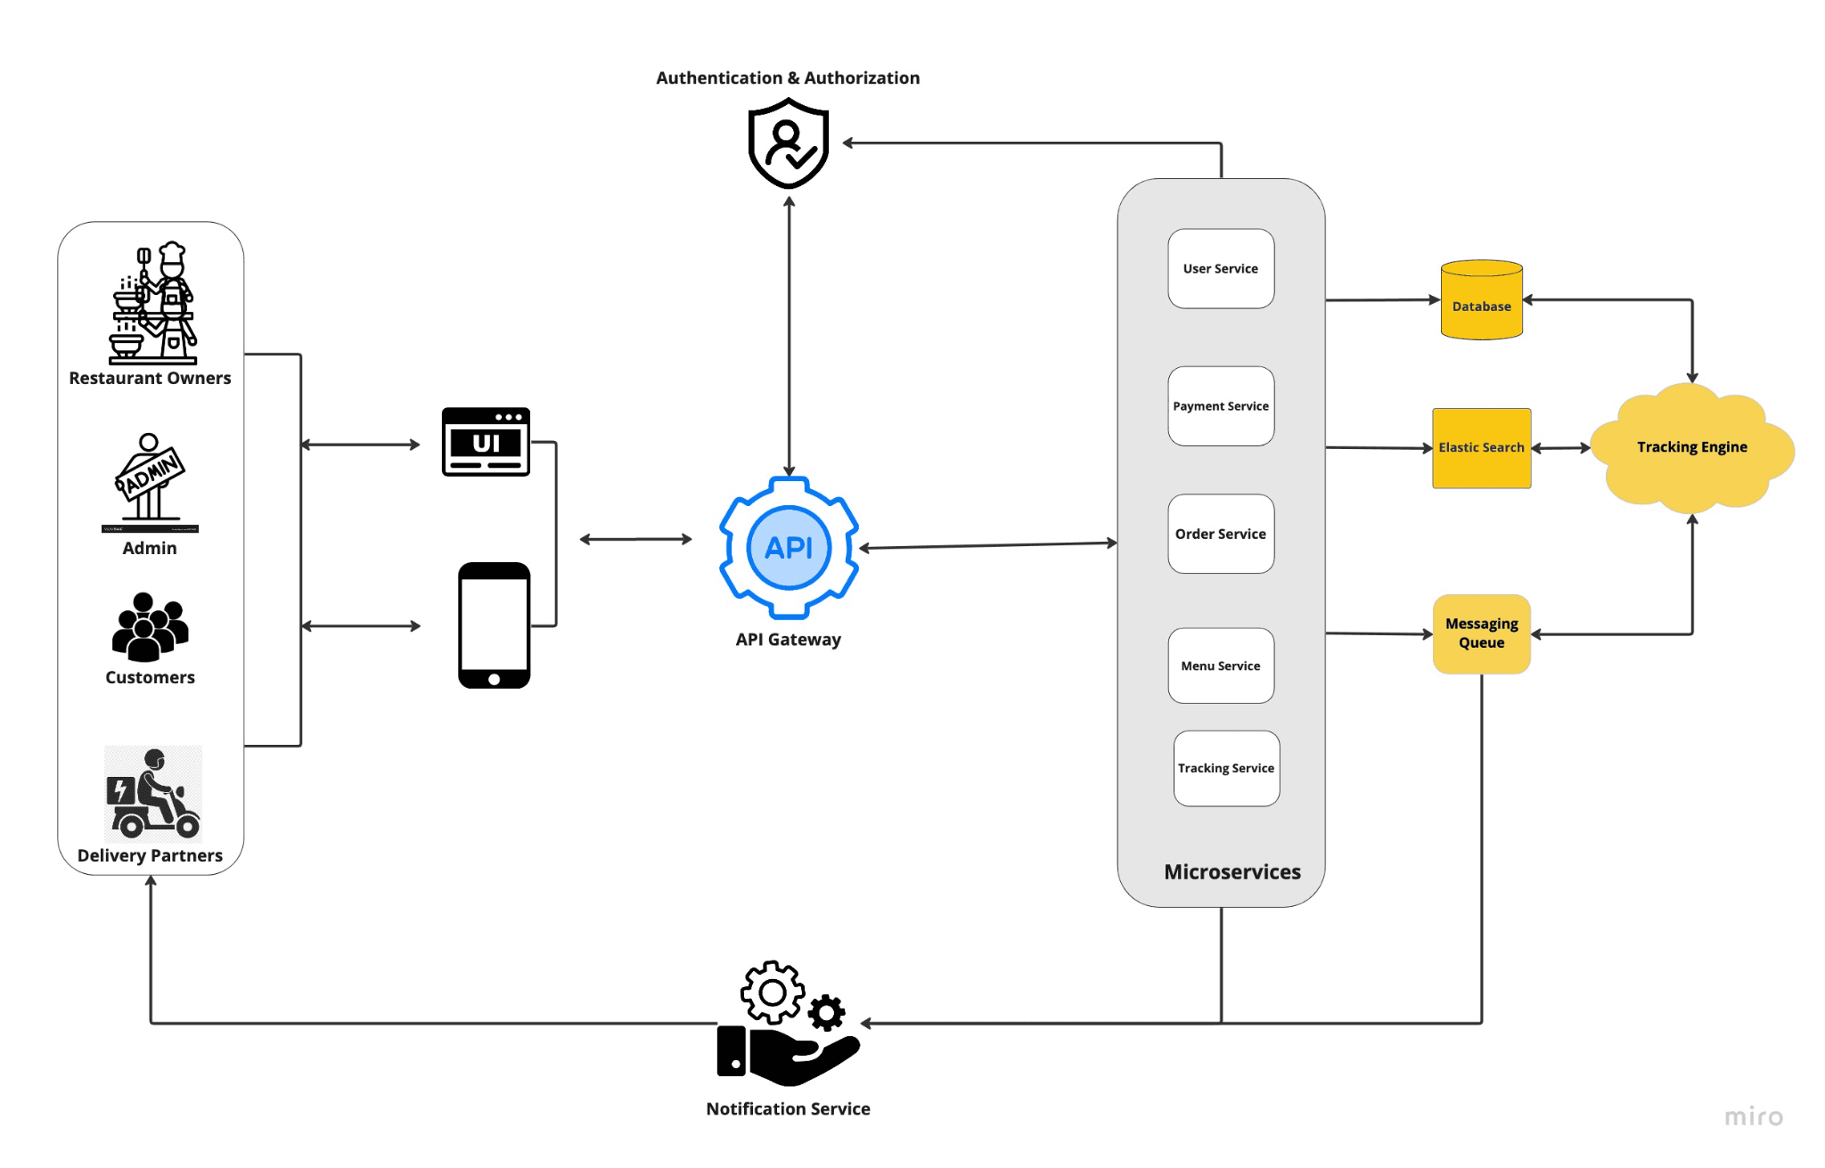
Figure 3.1: Existing System Architecture
Source: https://pratapsharma.com.np/architecture-of-food-delivery-app
18

3.3 Proposed System Architecture
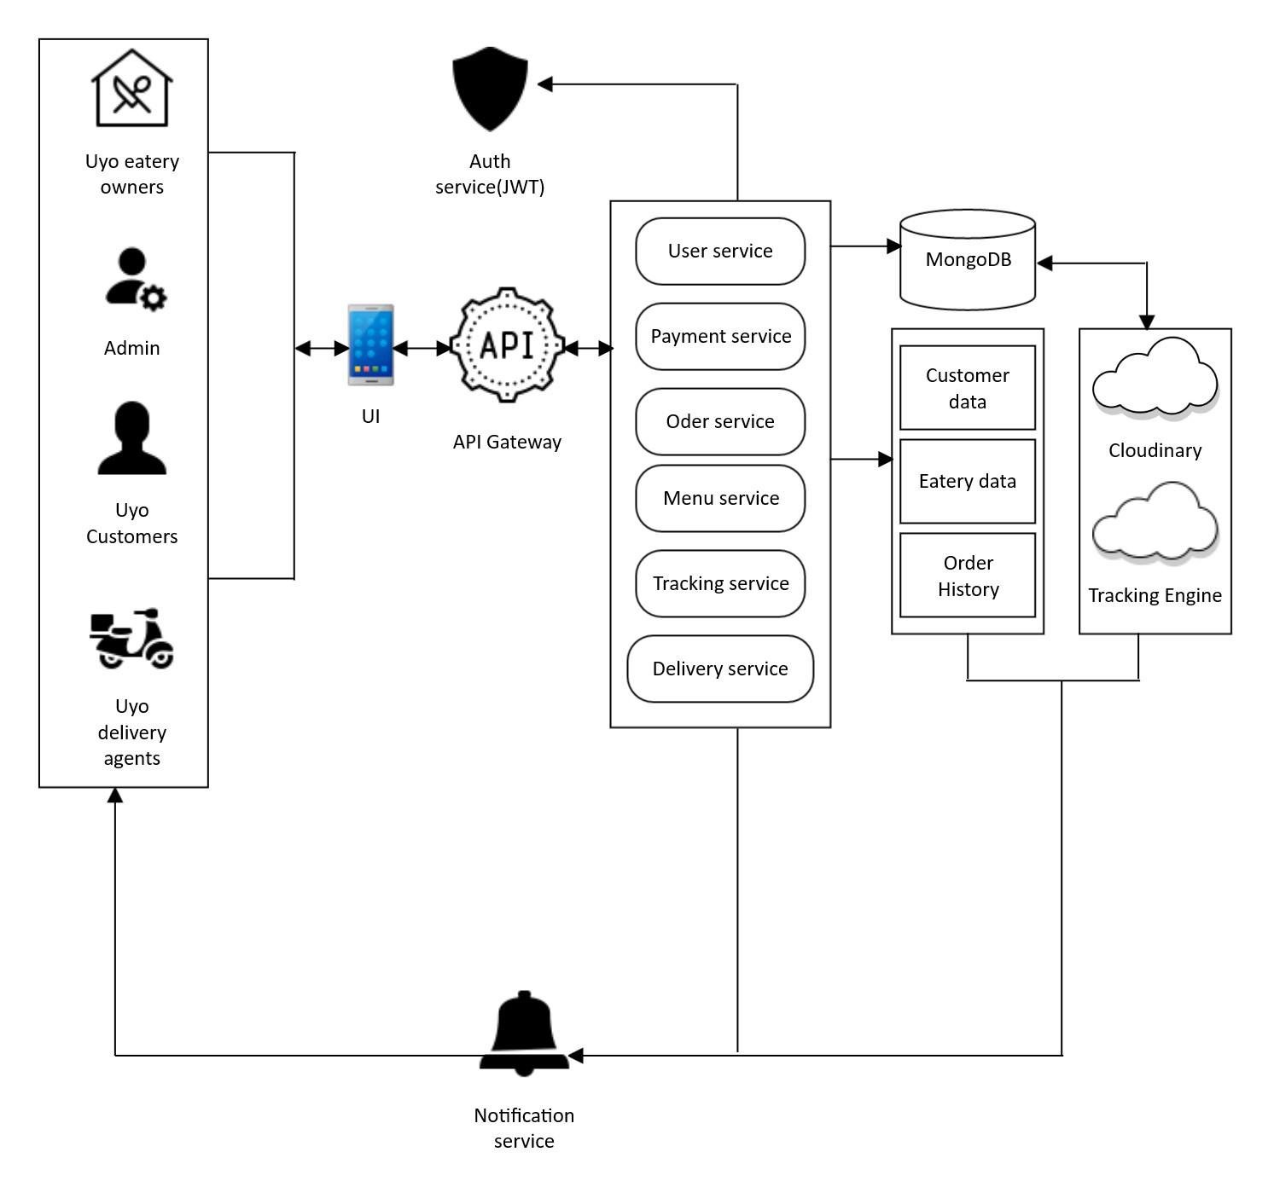
Figure 3.2: System Architecture

19

3.4 Component Of The Proposed System Architecture
The proposed architecture for the development of a web based application for seamless eatery ordering and delivery services is designed as a scalable and decoupled system based on a microservices pattern. This approach ensures that different parts of the application can be developed, deployed, and scaled independently, which is crucial for long-term maintenance and growth. The following section details each major component as illustrated in the proposed system architecture diagram.

- Actors (Users): These are the external entities that interact with the system. As the platform is exclusively focused on the Uyo metropolis, the actors are specifically defined as:
  - Uyo Eatery Owners: Vendors who manage their restaurant profiles, upload menus, and process incoming orders.
  - Admin: The system administrator responsible for overseeing the platform, managing users, and ensuring smooth operation.
  - Uyo Customers: The end-users who browse eateries, place food orders, and make payments.
  - Uyo Delivery Agents: The riders who accept delivery requests and transport orders from the eatery to the customer.

- UI (User Interface): This is the client-side of the application and the primary point of interaction for all actors. It will be developed as a single, responsive web application using React.js. This ensures a consistent experience across all devices, including desktops and mobile phones, without the need for separate native applications. The UI is responsible for displaying data and capturing user input, which it then sends to the backend via the API Gateway.
- API Gateway: This component acts as a single entry point for all client requests. When a user performs an action on the UI, the request is sent to the API Gateway. The gateway then intelligently routes the request to the appropriate backend microservice. This simplifies the client application, improves security by centralizing access control, and allows for efficient request management.
- Auth Service (JWT): This is a critical security component that works in conjunction with the API Gateway. When a user logs in, the Auth Service verifies their credentials and, if successful, issues a JSON Web Token (JWT). This token is then included in all subsequent requests from the UI. The API Gateway inspects this token to authenticate the user and authorize their access to different services, ensuring that only legitimate and permitted requests are processed.
- Microservices (Backend Logic): This is the core of the backend system, built using Node.js. Instead of a single, monolithic application, the business logic is broken down into several small, independent services. Each service has a specific responsibility:
  - User Service: Manages user registration, login, and profile information.
  - Payment Service: Handles all payment-related transactions, integrating with external payment gateways.
  - Order Service: Manages the entire lifecycle of an order, from placement to completion.
  - Menu Service: Responsible for all operations related to eatery menus, such as adding, updating, and retrieving food items.
20
  - Tracking Service: Manages real-time location data for delivery agents.
  - Delivery Service: Handles the logic for assigning delivery requests to available agents.
- MongoDB: This is the primary database for the application. As a NoSQL database, it stores data in a flexible, JSON-like format. It holds the core data for the platform, which is logically separated into collections such as Customer Data, Eatery Data, and Order History. Each microservice interacts with the MongoDB database to retrieve or store the data it needs.
- Cloudinary: This is a cloud-based service for managing images and videos. In this architecture, it will be used to store all media assets, such as restaurant logos and pictures of menu items. By offloading image storage to a specialized service like Cloudinary, the main application remains lightweight and performs better. The Menu Service will interact with Cloudinary to store and retrieve image URLs, which are then referenced in the database.

- Tracking Engine: This component is responsible for processing and managing real-time geospatial data. The Tracking Service feeds location updates from delivery agents into the Tracking Engine, which can then be used to display the rider's position on a map for the customer. This engine would be powered by a geo-service like the Google Maps API.
- Notification Service: This service is responsible for sending real-time alerts and notifications to users. For example, when an order status changes (e.g., "Preparing," "Out for Delivery"), the relevant microservice (e.g., the Order Service) sends a message to the Notification Service, which then pushes a notification to the customer's UI and the delivery agent's device. This keeps all parties informed throughout the order process.

3.5 System Modeling with UML
To ensure a clear and comprehensive design, the development of a web based application for seamless eatery ordering and delivery services system will be modeled using the Unified Modeling Language (UML). UML provides a standardized set of graphical notations for visualizing, specifying, constructing, and documenting the artifacts of a software-intensive system. The following diagrams will be used to represent different aspects of the system's design.

21

3.5.1 Use Case Diagram
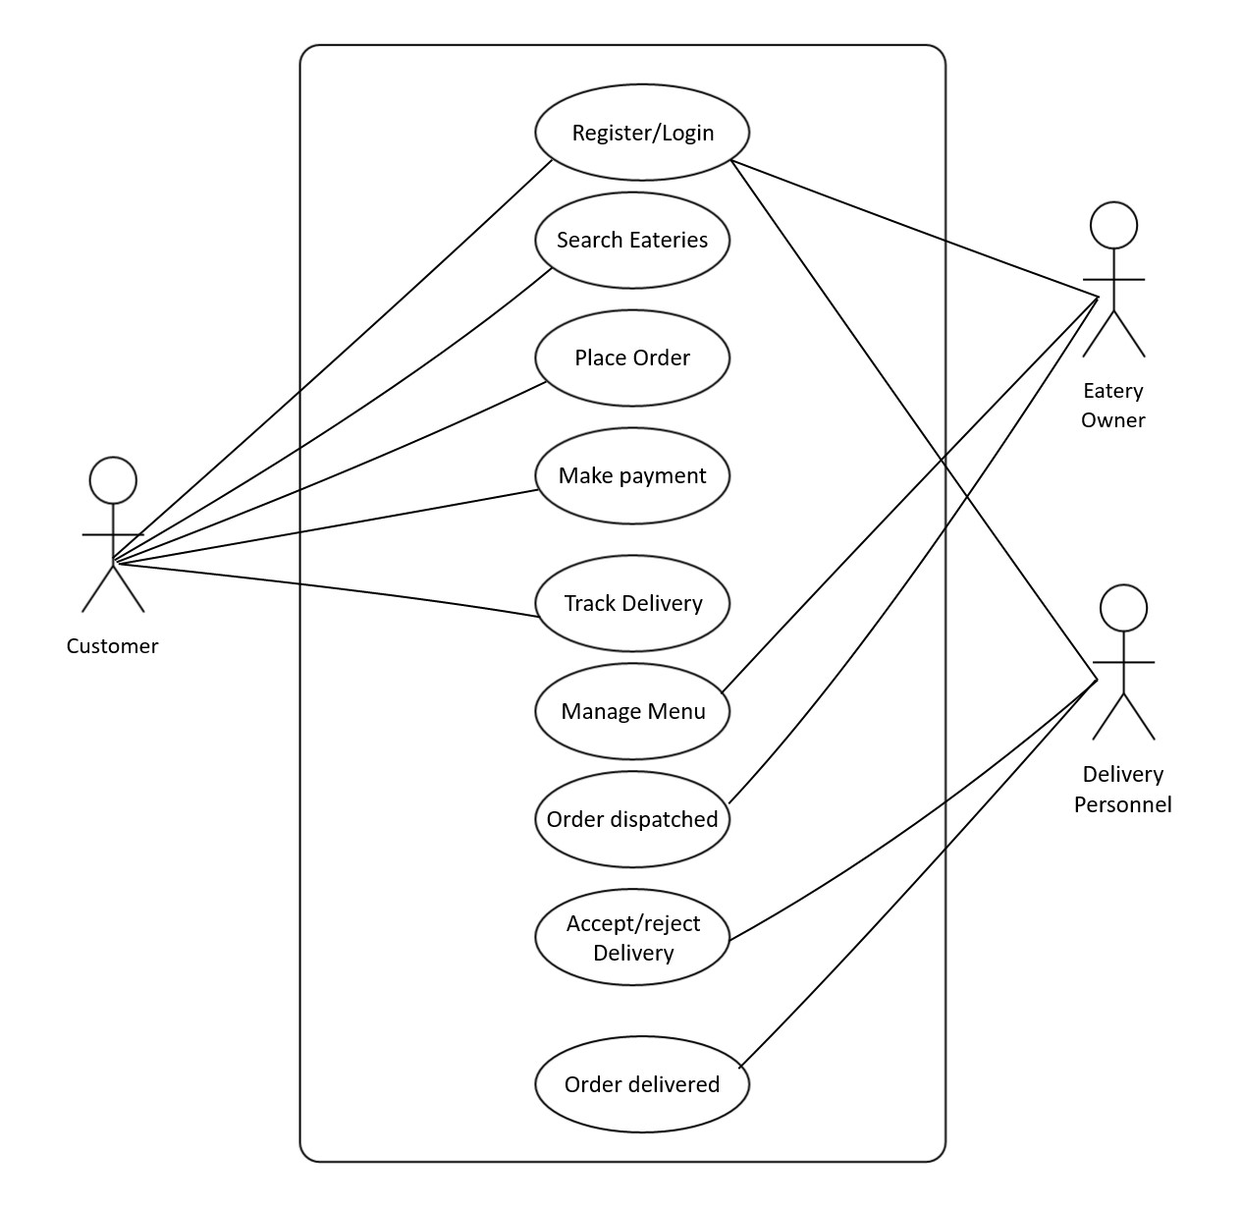
Figure 3.3: UseCase Diagram

22

3.5.2 Activity Diagram

This illustrates user flow during processes such as registration, ordering, and tracking.
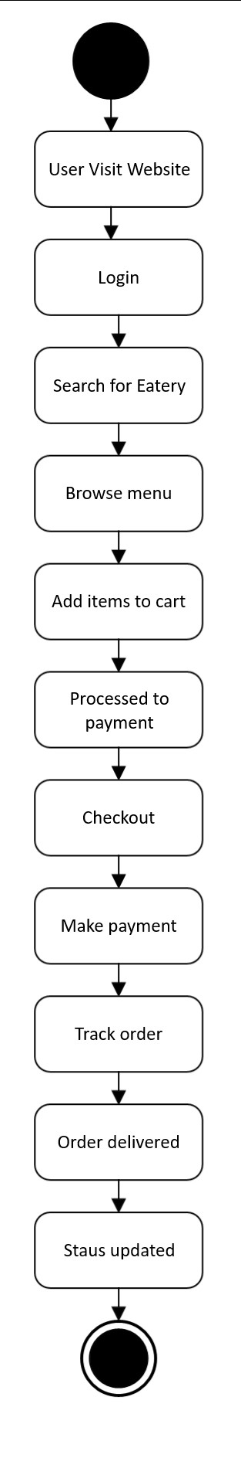

23
Figure 3.4: Activity Diagram

3.5.3 Sequence Diagrams
Sequence Diagrams will be used to model the dynamic behavior of the system by showing the time-ordered sequence of interactions between objects for specific scenarios. These diagrams are essential for detailing the logic of complex processes and understanding how different components of the system collaborate. A key sequence diagram will be developed for the "Order Placement and Payment" process. This diagram will illustrate the flow of messages from the
Customer interacting with the Frontend UI, which then sends API requests to the Backend Server. The Backend Server will, in turn, interact with the Database to create and store the order, and with the external Payment Gateway to process the transaction, finally returning a confirmation to the user.
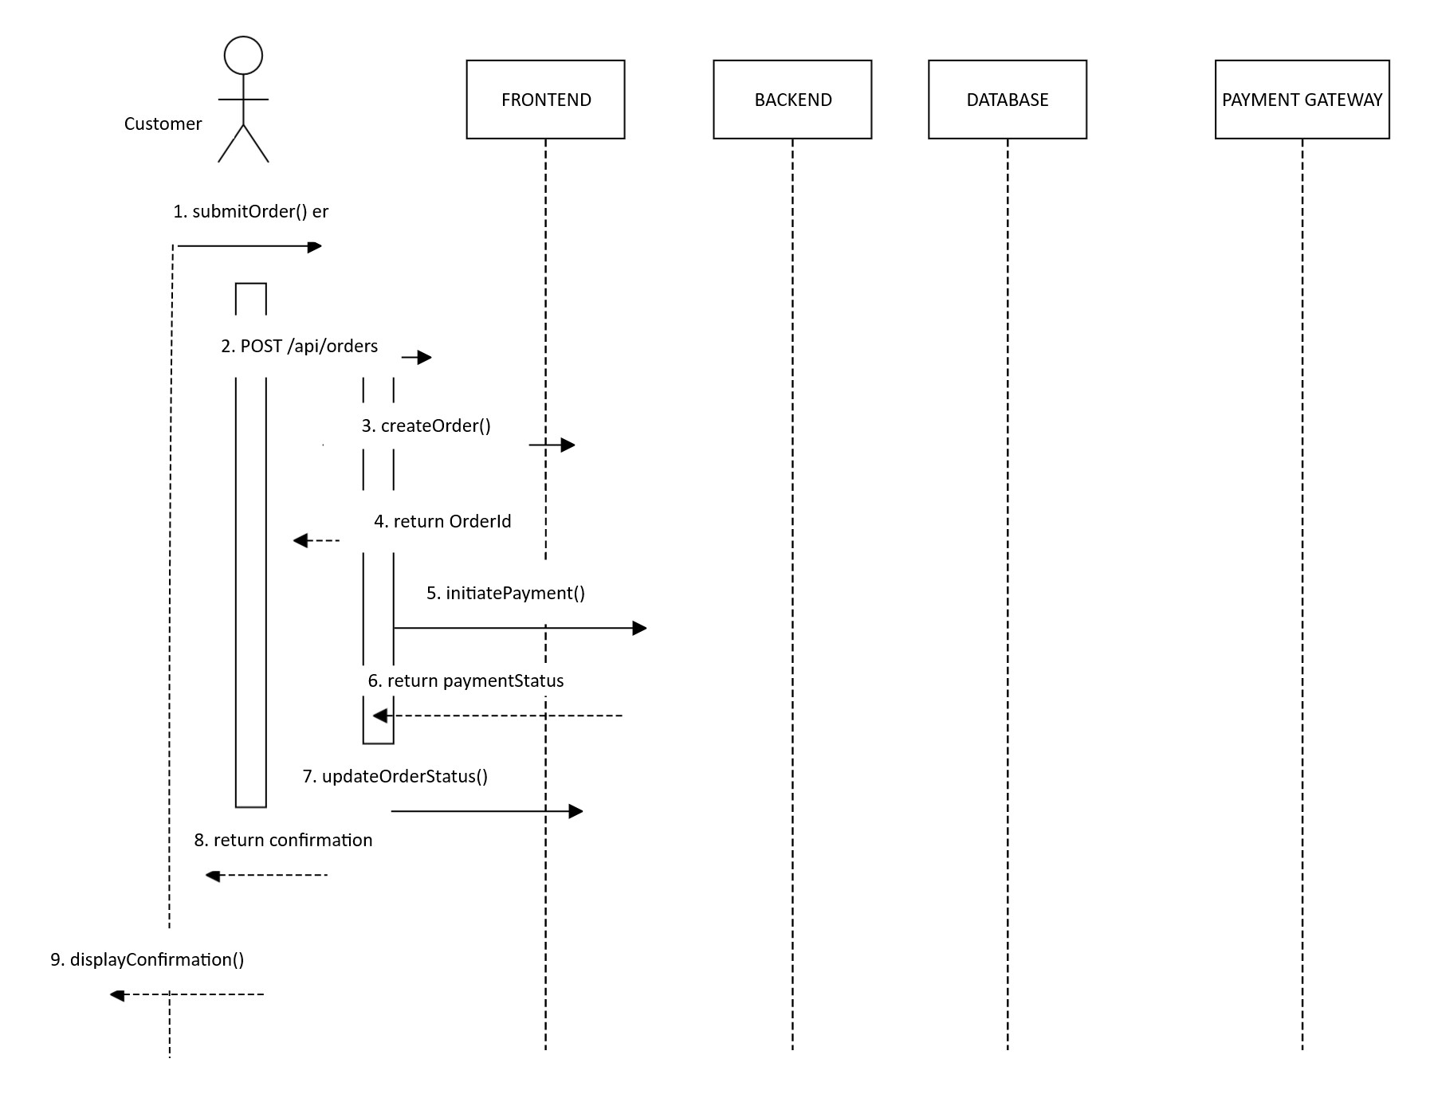
24
Figure 3.4 Sequence Diagram

3.5.3 Class Diagram
The Class Diagram will provide a static, structural view of the system's object-oriented design. It will depict the main classes of the system, their attributes (data members), methods (operations), and the relationships between them (such as association, inheritance, and aggregation). This diagram serves as a direct blueprint for both the database schema and the source code implementation. The primary classes will include User, Customer, EateryOwner, DeliveryPersonnel, Order, MenuItem, Payment, and Eatery, directly corresponding to the entities defined in the database design section. 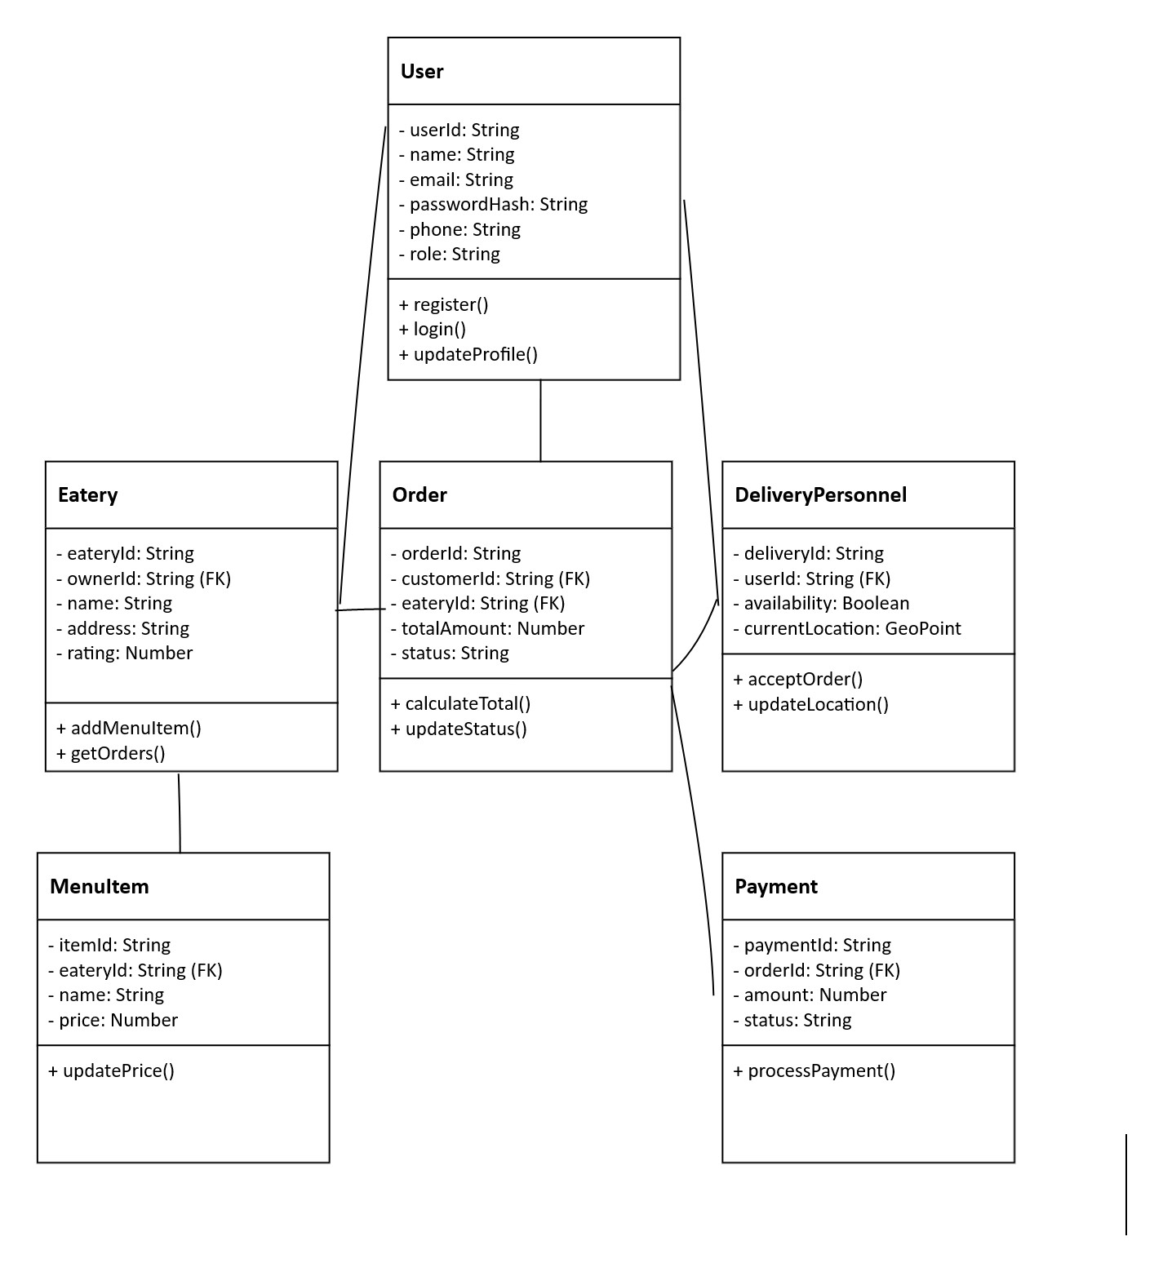
25
Figure 3.5 Class Diagram
3.6 Entity Relationship Diagram (ERD)
The Entity Relationship Diagram (ERD) for the development of a web application for seamless eatery ordering and delivery services describes the main entities, their attributes, and how they interact within the system. This system allows Customers to order for food from their favourite eatery as shown in Figure 3.6

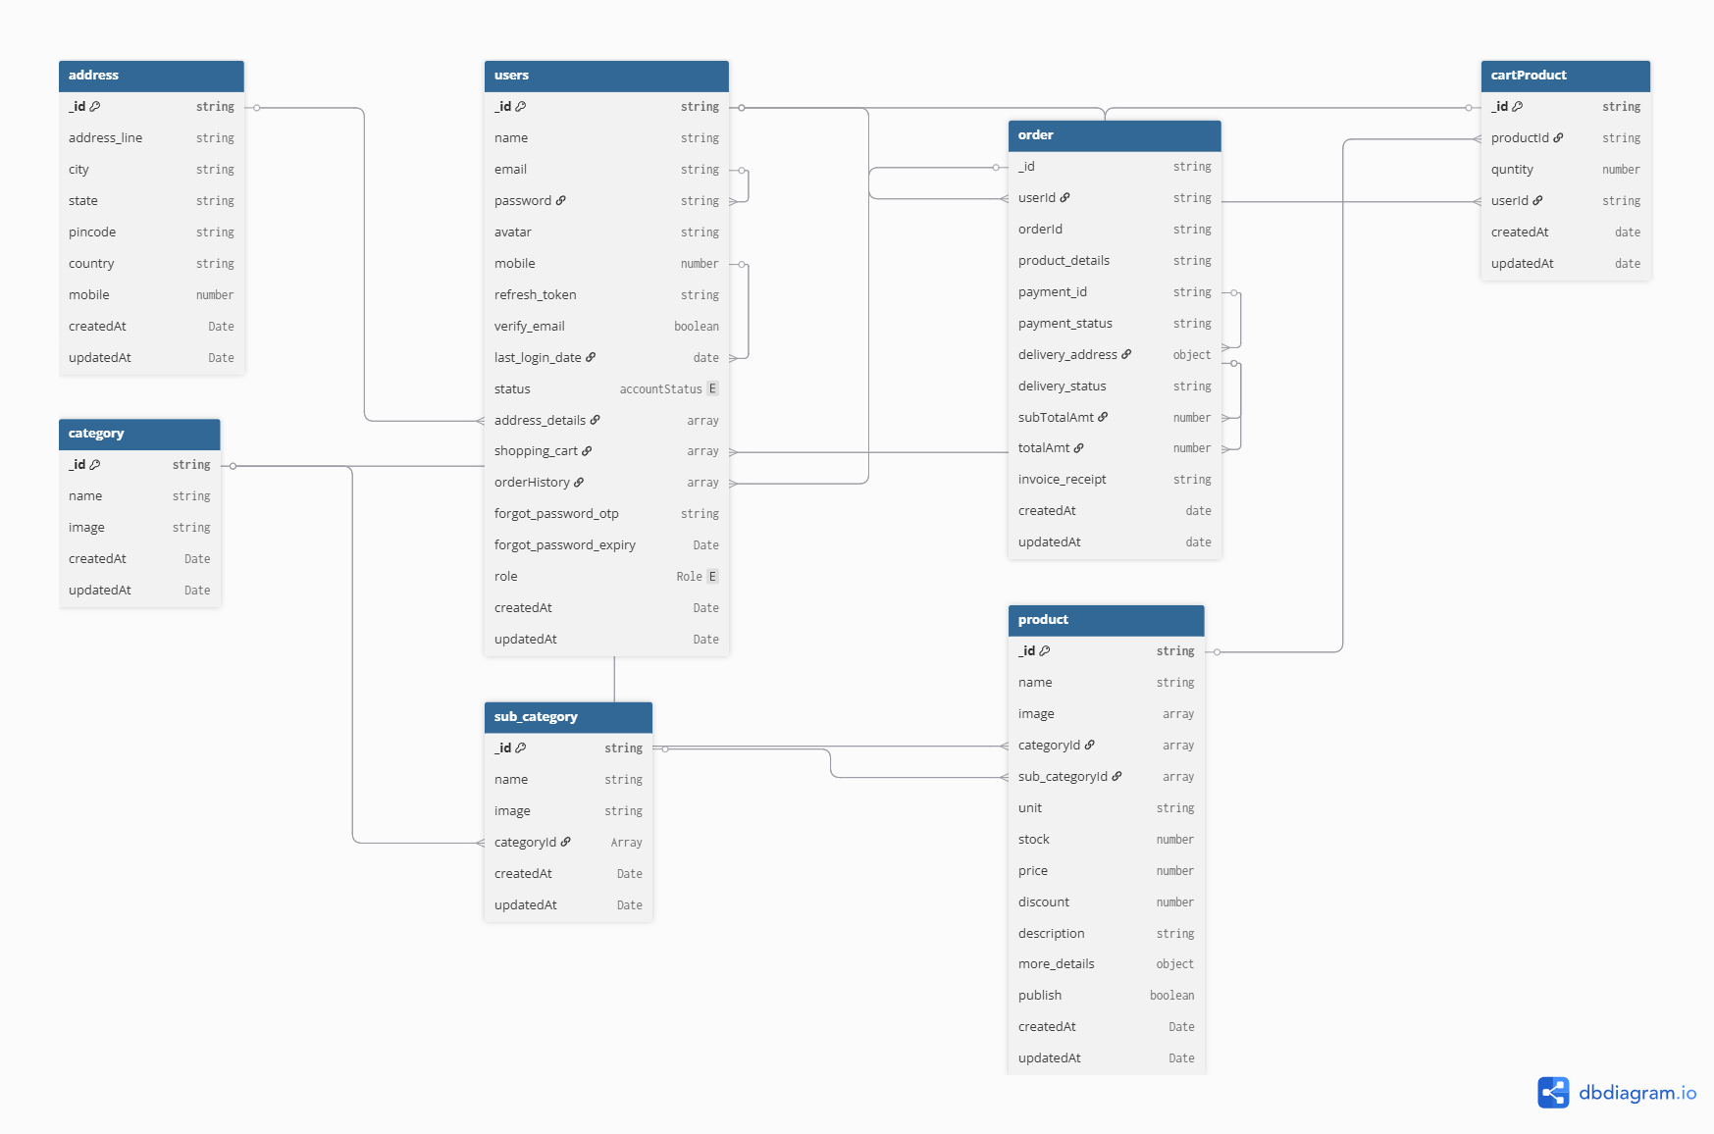
Figure 3.6: Entity Relationship Diagram.

26

CHAPTER FOUR

SYSTEM IMPLEMENTATION
This chapter details the implementation phase of the Swift-Bite project, where the conceptual designs and architectural plans outlined in Chapter Three were translated into a functional, tangible web application. This section provides a comprehensive account of the development process, from setting up the environment to the deployment of the final system. It covers the specific tools and technologies used, the implementation of the core system modules, the construction of the database, and the development of the user interface.

4.1 System Requirement
i. Hardware Requirement
CUP CORE i5
RAM 8GB DDR4
Storage 250 GB SSD
Network Gigabit Ethernet
ii. Software Requirement
Database MongoDB
Web Server
Application Framework Node. JS

4.2 Tools Used
The development and deployment of the Swift-Bite application leveraged a suite of modern tools to ensure an efficient and collaborative workflow. These tools supported various stages of the development lifecycle, from coding and testing to version control and deployment.
- Integrated Development Environment (IDE): Visual Studio Code (VS Code) was the primary code editor used for both frontend and backend development. Its lightweight nature, extensive library of extensions for JavaScript and React, integrated terminal, and robust debugging capabilities made it an ideal choice.
- API Testing Platform: Postman was used extensively for testing the backend RESTful API endpoints during development. It enabled the creation and execution of HTTP requests to validate endpoint functionality, verify responses, and ensure the API was functioning as expected before integration with the frontend.
- Version Control System: Git was used for version control, with GitHub serving as the remote repository. This facilitated code tracking, branch management, and collaboration, providing a complete history of the project's development.
- Development and Deployment Platforms:
  - Nodemon: This utility was used during backend development to automatically restart the Node.js server upon detecting file changes, which significantly accelerated the development and debugging cycle.
  - Render.com & GitHub: These platforms were used for the continuous integration and deployment of the frontend React application. Linking the GitHub repository to these services allowed for automatic builds and deployments whenever new code was pushed to the main branch.

27

4.3 Technology used
The development of a web based application for seamless eatery ordering and delivery services is built on the MERN stack, a powerful and popular technology stack for creating full-stack web applications using JavaScript across all tiers. This unified language approach streamlines development, allowing for seamless data flow.

- Frontend (Client-Side):
  - React.js: A JavaScript library for building dynamic and responsive user interfaces. Its component-based architecture was used to create reusable UI elements.
  - React Router: This library was used to handle client-side routing, enabling navigation between different pages in the single-page application.
  - Axios: A promise-based HTTP client used to make API requests from the React frontend to the Node.js backend.
- Backend (Server-Side):
  - Node.js: A JavaScript runtime environment that allows for the execution of JavaScript code on the server. Its non-blocking, event-driven architecture is highly efficient for handling concurrent requests.
  - Express.js: A minimal and flexible web application framework for Node.js, used to build RESTful APIs.
- Database:
  - MongoDB: A NoSQL, document-oriented database used to store all application data.
  - Mongoose: An Object Data Modelling (ODM) library used to create schemas and models, simplifying the interaction between the Node.js application and the MongoDB database.

4.4 Installed Software
To create a local development environment capable of running and testing the application, the following foundational software had to be installed on the developer's machine:

- Node.js: This is the core requirement, as it provides the runtime environment for the backend server. The installation of Node.js also includes the Node Package Manager (npm), which is essential for managing all project dependencies (both frontend and backend libraries).
- MongoDB Community Server: For local development and testing, a local instance of the MongoDB database was installed. This allowed the application to connect to a database on the same machine, removing the dependency on an internet connection for basic database operations.
- Git: The Git version control system was installed to manage the source code, track changes, and interact with the remote GitHub repository.

28

4.5 Database Implementation
The database schema, designed in Chapter Three, was implemented using MongoDB and the Mongoose ODM library. MongoDB's document-based structure is well-suited for the MERN stack, as it stores data in a JSON-like format (BSON) that maps directly to JavaScript objects used in the application. Mongoose schemas were defined for each of the core entities to enforce data structure and validation. For example, the Order schema was implemented to include fields for the user, the restaurant, an array of ordered items, the total amount, delivery address, and the order status. This schema also includes references to the User, Restaurant, and MenuItem collections, establishing the relationships between them. This approach ensures data integrity while retaining the flexibility that is a key advantage of NoSQL databases.

4.6 User Interface Implementation
The user interface (UI) of the development of a web based application for seamless eatery ordering and delivery services was developed using the React.js library, focusing on creating a responsive, intuitive, and seamless user experience. The UI was built using a component-based architecture, which promotes reusability and maintainability.
Key UI components developed include:
- Navbar: Provides consistent navigation across the application.
- RestaurantCard: A reusable component to display summary information for each eatery, such as name, cuisine type, and rating.
- MenuItem: A component to display individual food items with details and an "Add to Cart" button.
- Cart: A component that displays the items in the user's shopping cart, allowing for quantity adjustments and removal of items.
- CheckoutForm: A form for users to enter their delivery and payment information.
State management was handled using React's useState and useEffect hooks for component-level state, and the useContext hook for global state like the shopping cart and user authentication status. This ensures that data is efficiently shared across the application, and the UI updates reactively to changes in the application's state.

4.7 Snapshots/Snippets of the Project
This section would typically contain visual evidence of the implemented system. This includes screenshots of the main pages of the development of a web based application for seamless eatery ordering and delivery services, such as the homepage displaying a list of eateries, a restaurant's menu page, the shopping cart, the order tracking interface, and the eatery owner's dashboard. Code snippets illustrating key functionalities, such as an API endpoint

29
in Express.js or a React component, would also be included to provide insight into the development process.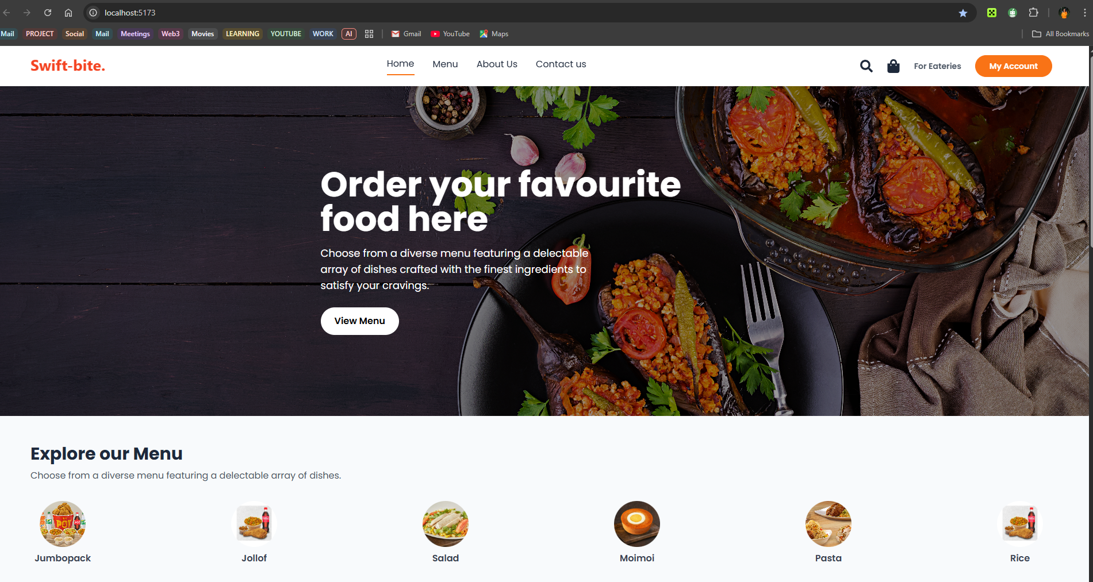
Figure 4.1: Dashboard

30
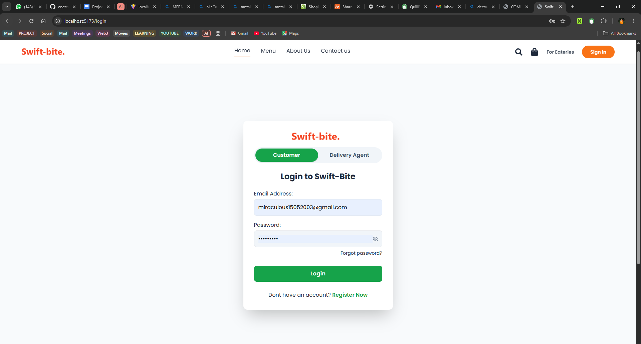
Figure 4.2: Customer sign-in page
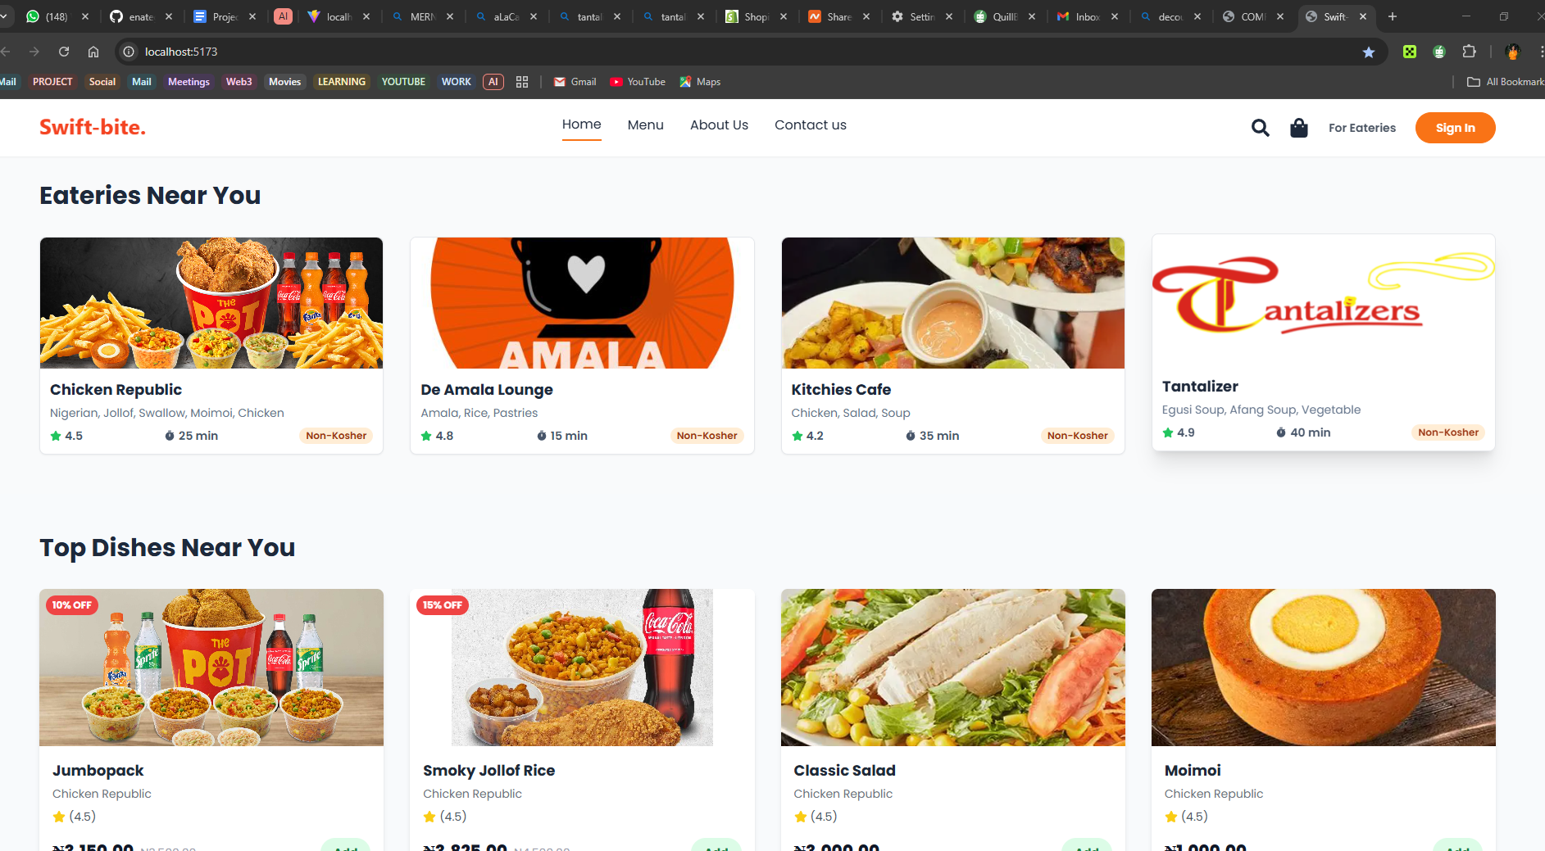
31
Figure 4.3: Eateries near customer
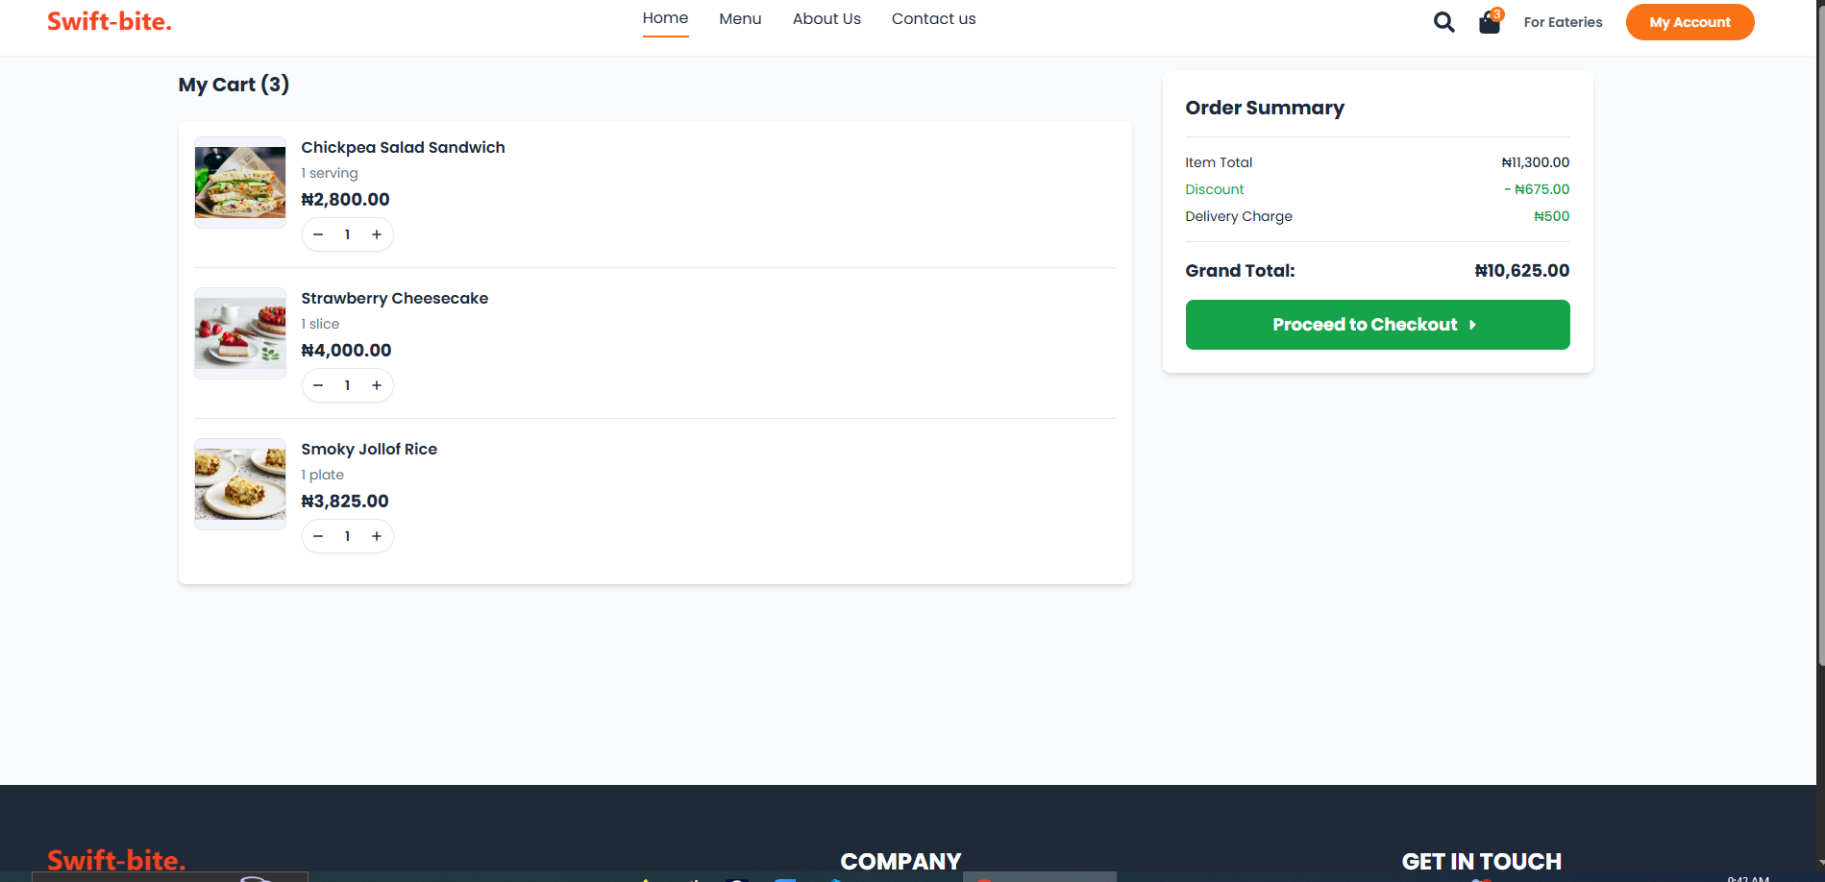
Figure 4.4: Cart

32
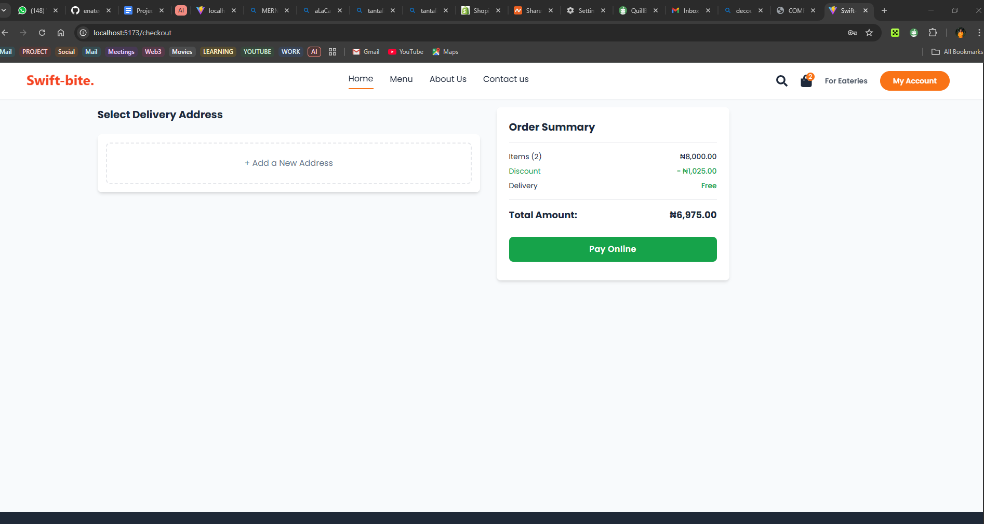
Figure 4.5: Payment
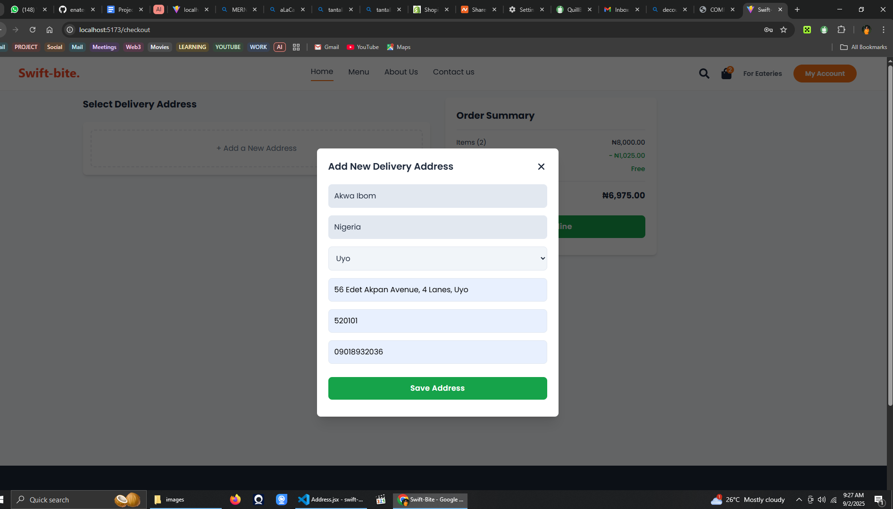
33
Figure 4.6: Add address
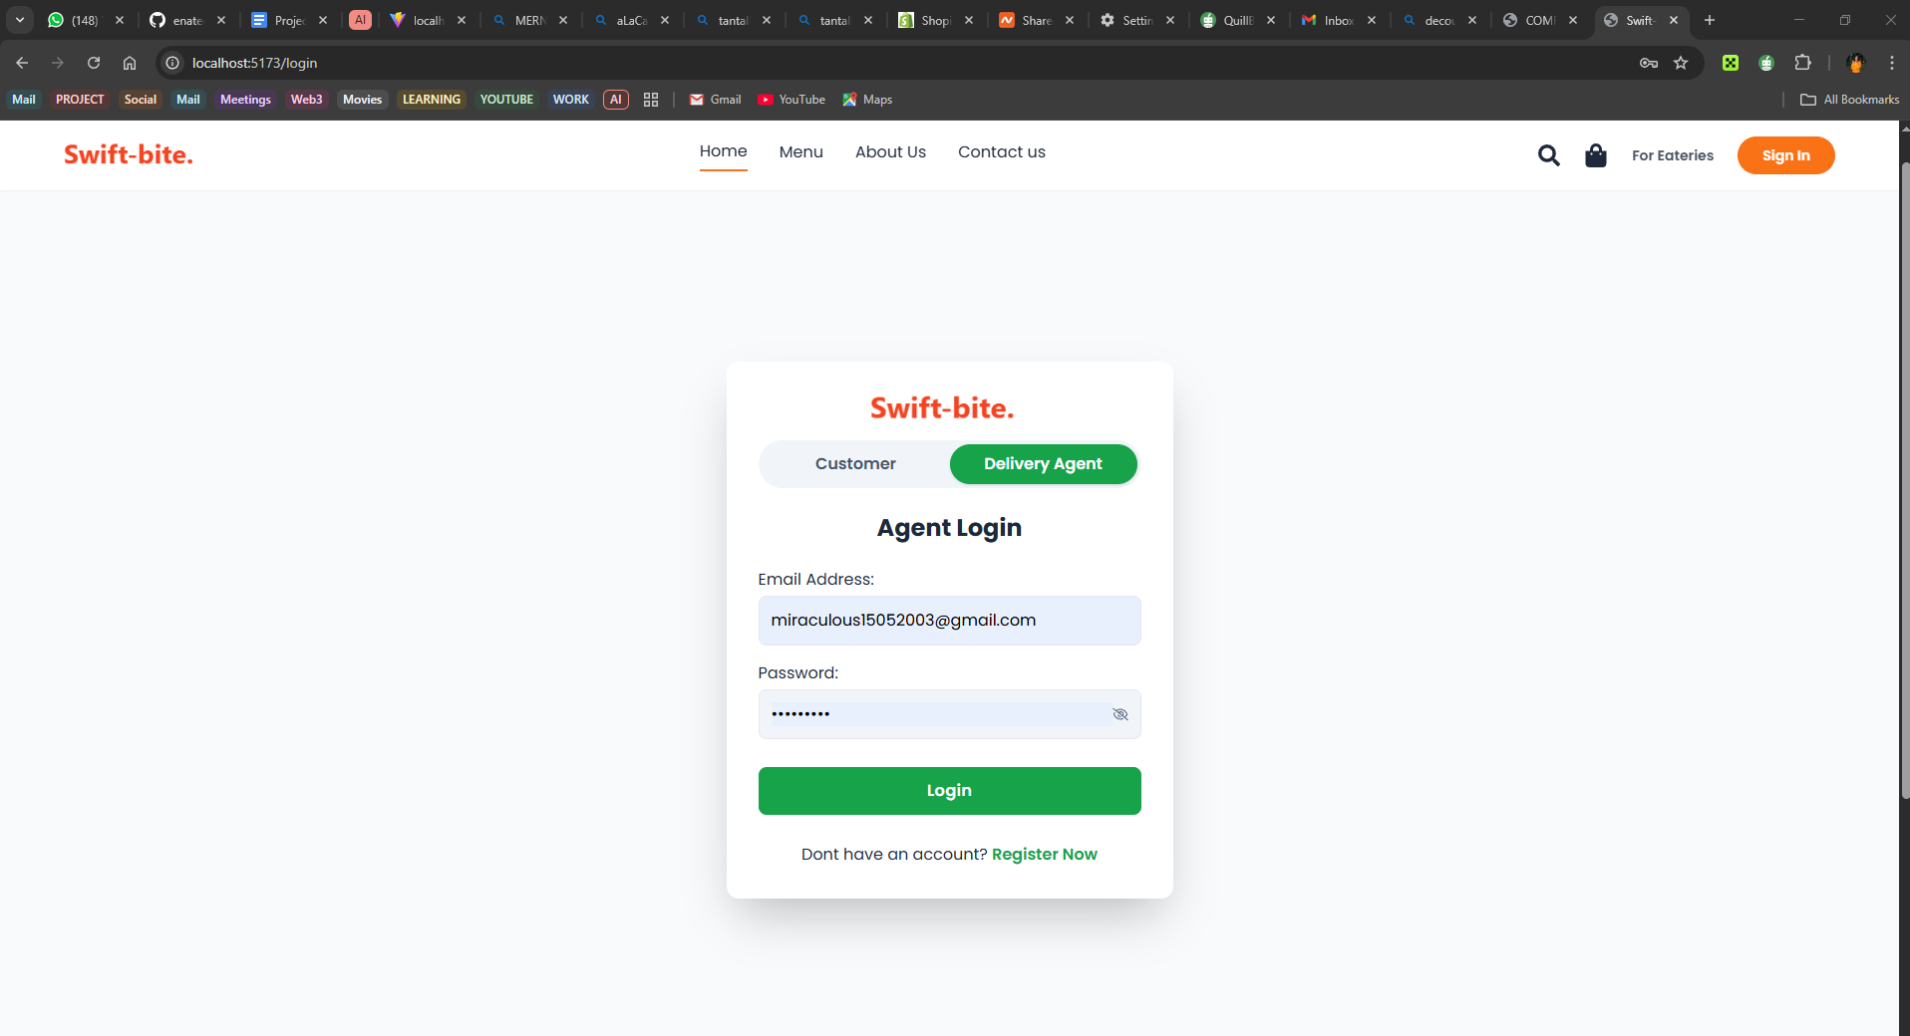
Figure: 4.7 Agent sign-in page

34
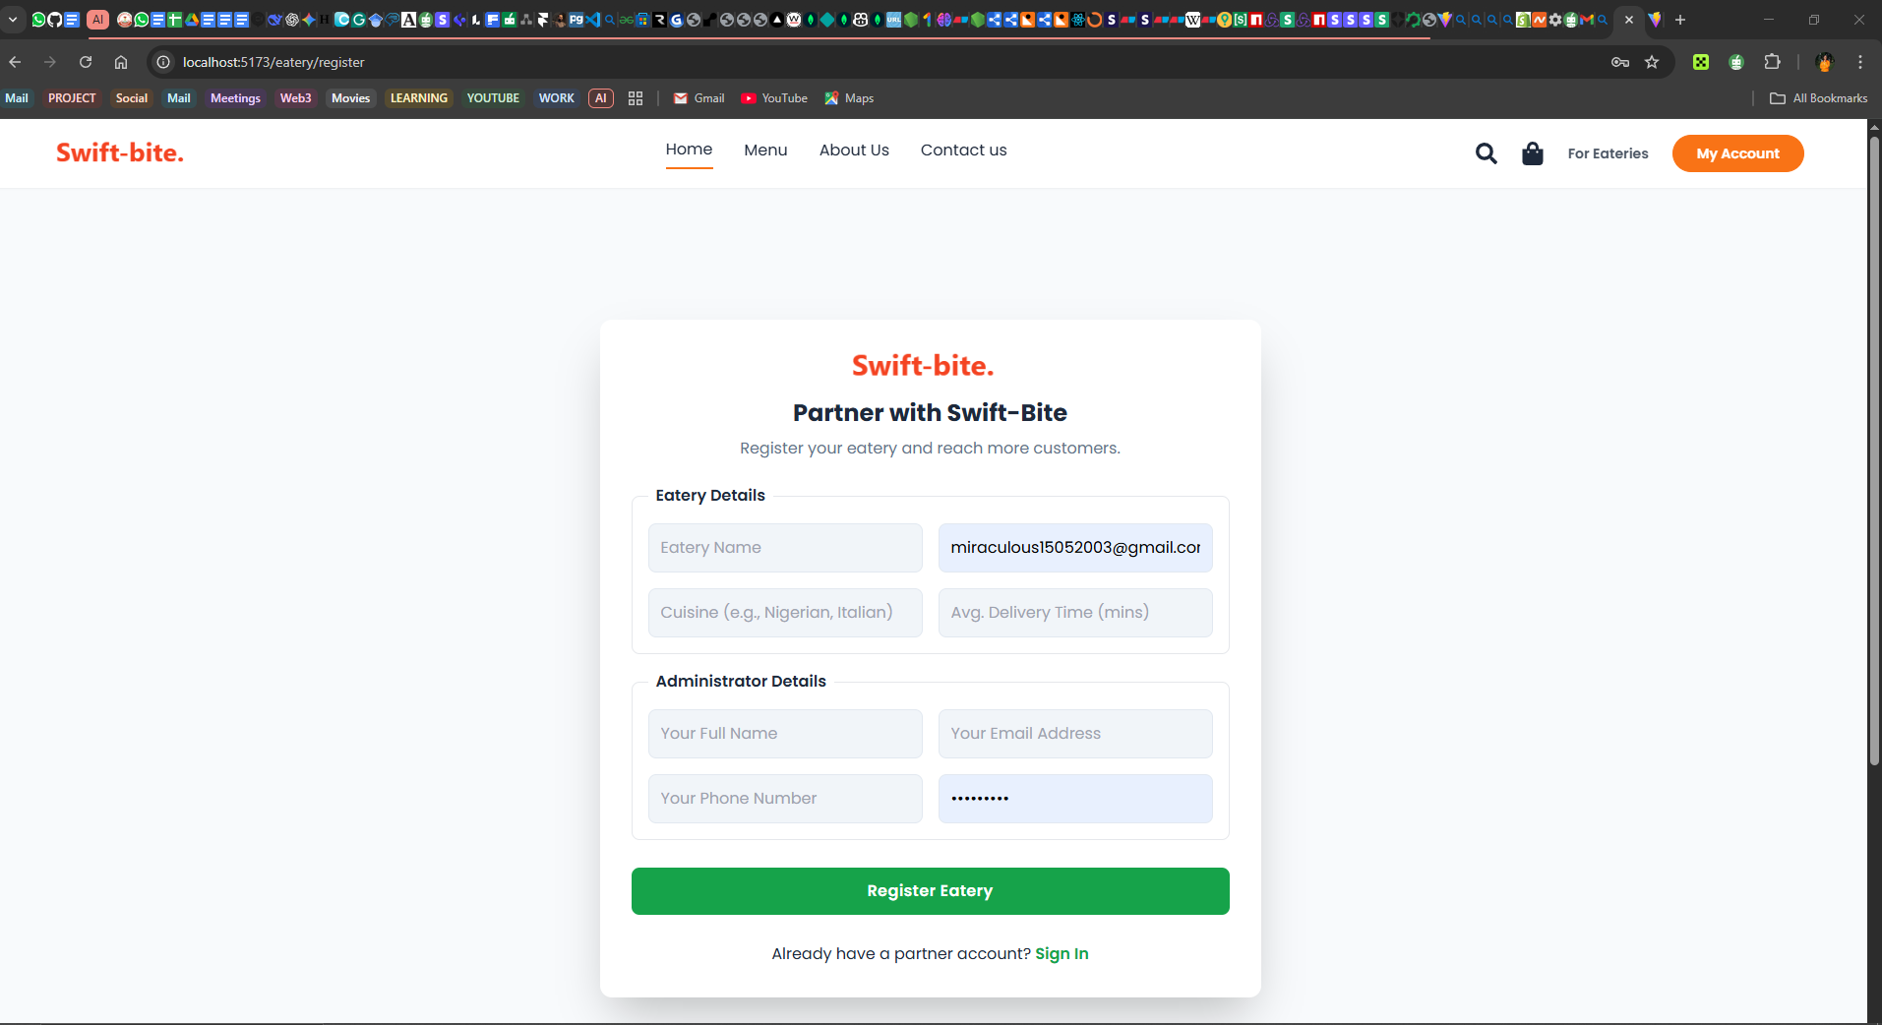
Figure 4.8: Eatery sign-in page
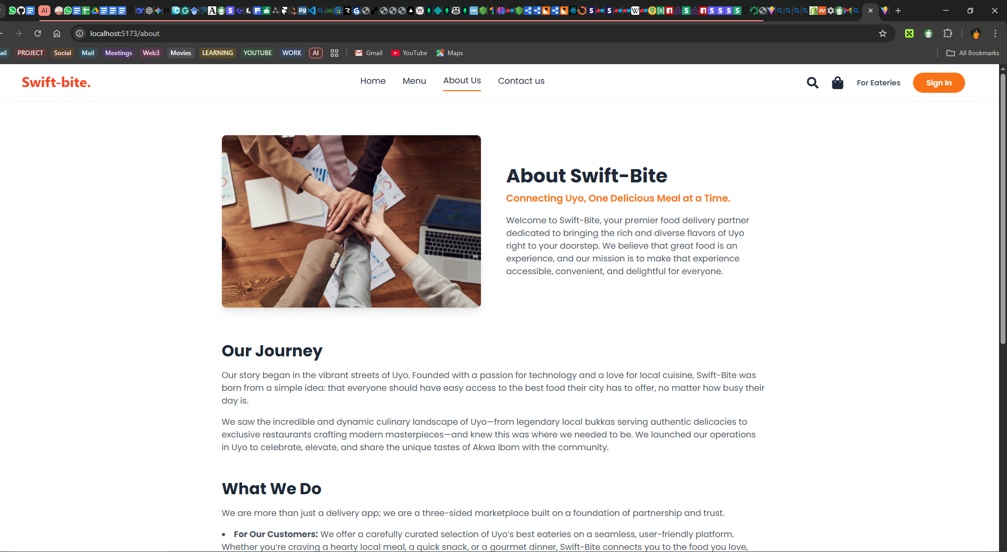
35
Figure 4.9: About
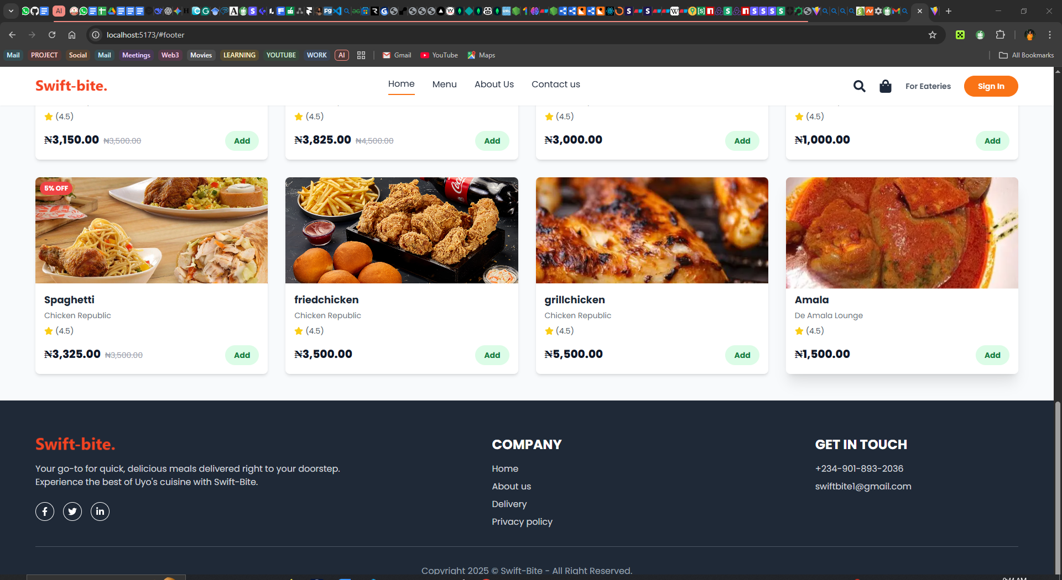
Figure 4.10: Contact Us

36

4.8 Testing and Debugging
A rigorous testing and debugging strategy was employed to ensure the quality, stability, and reliability of the development of a web based application for seamless eatery ordering and delivery services. The testing process was multi-layered, encompassing different types of tests to validate the system at various levels.
- Unit Testing: This focused on testing the smallest individual components of the application in isolation. For the React frontend, Jest and React Testing Library were used to test individual components to ensure they render correctly and respond to user interactions as expected. For the backend, unit tests were written for individual functions and business logic to verify their correctness.
- Integration Testing: This phase focused on testing the interaction between different parts of the system. For the backend, tools like SuperTest were used to test the API endpoints, ensuring that they correctly handle
37
requests, interact with the database, and return the expected responses. This verified that the frontend and backend could communicate effectively.
- End-to-End (E2E) Testing: E2E testing was conducted to simulate real user workflows from start to finish. A framework like Cypress was used to automate user interactions in a real browser environment. Test scenarios included a user registering, logging in, browsing eateries, placing an order, and completing the payment process. This level of testing is crucial for verifying that all system components work together cohesively in a production-like environment.
Common debugging strategies were employed throughout the development process. On the frontend, React Developer Tools and the browser's built-in developer tools were used to inspect component states and debug UI issues. On the backend, console.log() statements and the debugging features in VS Code were used to trace the execution flow and inspect variables. Tools like Nodemon and Morgan were also instrumental in providing real-time feedback and logging HTTP requests, which streamlined the debugging process.

4.9 Evaluation Results
The comprehensive testing process yielded positive results, confirming that the web application successfully meets the functional and non-functional requirements established in Chapter Three. E2E tests demonstrated that all core user flows from registration to order completion and tracking function as intended without critical errors. Performance tests indicated that page load times were within the acceptable threshold of 3 seconds, and the system remained responsive under simulated concurrent user loads. The implementation of security best practices, such as password hashing and secure API endpoints, was validated. The final deployed application provides a stable and reliable platform for online food ordering and delivery within the specified scope.

4.10 Challenges Encountered
Several challenges were encountered during the development of a web based application for seamless eatery ordering and delivery services. One of the primary technical hurdles was the integration of third-party services,
30
particularly the payment gateway and the Google Maps API. Ensuring secure and reliable communication with these external services required careful implementation and thorough testing. Managing real-time data, such as live order status updates and GPS location tracking, presented another challenge, necessitating the use of efficient data handling techniques to ensure the UI remained responsive. On the frontend, managing a complex global state for features like the shopping cart and user authentication required a well-structured approach to avoid inconsistencies and bugs. Finally, ensuring the application was secure against common web vulnerabilities, such as Cross-Site Scripting (XSS) and Cross-Site Request Forgery (CSRF), required diligent adherence to security best practices throughout the development process.

38

CHAPTER FIVE

SUMMARY, RECOMMENDATIONS, AND CONCLUSION

5.1 Recommendations
Based on the findings and experiences from this project, the following recommendations are proposed for various stakeholders:
- For Local Eatery Owners: It is highly recommended that local eateries in Uyo embrace digital platforms like the web based application for seamless eatery ordering and delivery services. Adopting this technology can lead to significant improvements in operational efficiency, a reduction in order errors, and access to a wider customer base, ultimately driving business growth and increasing competitiveness in an evolving market.
- For Future Developers: Developers undertaking similar projects in the Nigerian context should prioritize building lightweight and highly performant applications optimized for potentially inconsistent internet connectivity. A mobile-first design approach is also recommended, given the high rate of smartphone penetration. Furthermore, focusing on a simple and intuitive User Experience (UX) is crucial to ensure high adoption rates among users with varying levels of digital literacy.
- For Policymakers: As the gig economy continues to grow, there is a need for clear and supportive regulatory frameworks that protect the rights of gig workers while fostering innovation. Policies that encourage digital literacy and support the adoption of technology by small and medium-sized enterprises (SMEs) would also be beneficial for the growth of the digital economy.

5.2 Summary
This project documented the design, development, and implementation of a web-based application for seamless eatery ordering and delivery services tailored for the Uyo metropolis. The study was initiated to address the prevalent issues of inefficient manual order management and unreliable delivery infrastructure faced by local eateries. The primary aim was to create a centralized digital platform that enhances customer convenience, improves operational efficiency for restaurants, and contributes to the local digital economy

5.3 Conclusion
The development of a web based application for seamless eatery ordering and delivery services project has successfully achieved its central aim of developing a functional and seamless web application for eatery ordering and delivery. The final product effectively addresses the problems of poor order management and fragmented delivery services identified in the Uyo metropolis. By providing an intuitive digital interface for customers and a powerful management dashboard for eateries, the platform is poised to significantly enhance the efficiency of the local food service industry.

39

REFERENCES
Abdullahi, R., et al. (2021). Factors influencing adoption of online food delivery. African Journal of Information
Systems.
Adebayo, S., et al. (2022). A comparative study of architectural approaches for food delivery applications in
low-bandwidth environments. African Journal of Information Technology.
Adegoke, F. (2023). Alternative delivery networks in Nigeria. Logistics Management Review, 17(3), 45-60.
Adeleke, R., et al. (2021). Platform economics in Lagos' food sector. Nigerian Journal of Economic Studies, 14(3),
112-129.
Adeleke, R., et al. (2023). The role of culturally familiar design elements in user engagement in Nigerian
urban centers. Journal of African Digital Experiences.
Ahmad, A., et al. (2023). Consumer preferences in self-service technologies.
Journal of Service Technology.
Akintola, C. T. (2025). Consumer behaviour towards online food delivery services -
A study of undergraduate students of the University of Ibadan. [Master's thesis, University of Ibadan].
Amazon Web Services. (n.d.). What is a web application? Retrieved
from https://aws.amazon.com/what-is/web-application/
Apiko. (2025, January 7). Payment gateway integration: A comprehensive
guide. https://apiko.com/blog/payment-gateway-integration/
Atlassian. (n.d.). 5 advantages of microservices [+ disadvantages]. Retrieved
from https://www.atlassian.com/microservices/cloud-computing/advantages-of-microservices
Atlassian. (n.d.). What is a UML diagram: Types, examples, and uses. Retrieved
from https://www.atlassian.com/work-management/project-management/uml-diagram
Bhatnagar, R. (2006). The evolution of quick service to self-service in the restaurant industry.
Cornell Hospitality Quarterly.
Bluestout. (n.d.). Ecommerce operations management. Retrieved
40
from https://bluestout.com/ecommerce/ecommerce-operations-management/
Buske. (n.d.). What is seamless logistics. Retrieved from https://www.buske.com/what-is/seamless-logistics
Chen, L. (2020). Urban delivery route optimization. Transportation Research Part C, 78, 145-160.
Chukwuma, D., and Okafor, J. (2021). Security concerns in online food ordering platforms:
A Nigerian user perspective. Journal of FinTech in Emerging Economies.
Codecademy. (n.d.). What is a web application? Complete guide to web apps.
Retrieved from https://www.codecademy.com/article/what-is-a-web-application-complete-guide-to-webapps
Constructor. (2025, March 6). AI recommendation engines in
ecommerce. https://constructor.com/blog/ai-recommendation-engines-in-ecommerce
Cypress. (n.d.). How Cypress works. Retrieved from https://www.cypress.io/how-it-works
Dixit, A. (2023, January 30). Database design for a food delivery app like Zomato/Swiggy. Medium. https://medium.com/towards-data-engineering/database-design-for-a-food-delivery-app-like-zomato-swiggy-86c16319b5c5
Enatega. (n.d.). A step-by-step guide on food delivery app
architecture. https://enatega.com/food-delivery-app-architecture/
Federal Aviation Administration. (2025, July 31). Package delivery by drone
(Part 135). https://www.faa.gov/uas/advanced_operations/package_delivery_drone
Federal Competition and Consumer Protection Commission. (2018). Federal Competition and
Consumer Protection Act, 2018.
Federal Republic of Nigeria. (2023). Nigeria Data Protection Act, 2023.
Gan, C. C. (2000). Online fast food restaurant ordering system. UUM Electronic Theses and
Dissertations. https://ep3.uum.edu.my/499/
Google Developers. (n.d.). Shipment tracking | Maps JavaScript API. Retrieved
from https://developers.google.com/maps/documentation/javascript/reference/journey-sharing-shipment-tracking
40
Harness. (2025, June 26). Unit testing vs integration testing: Key differences and
best practices. https://www.harness.io/harness-devops-academy/unit-testing-vs-integration-testing
Ibrahim, Y., and Bello, A. (2021). Low-literacy interface design.
Human-Computer Interaction Africa, 4(1), 23-38.
Ibrahim, A., and Mohammed, B. (2022). Application of queuing theory to food delivery systems in medium-sized Nigerian cities.
Journal of Urban Logistics.
Interaction Design Foundation. (2016, June 1). What is user experience
(UX) design? https://www.interaction-design.org/literature/topics/ux-design?page=7
Johnson, M., Williams, K., and Davis, P. (2021). Global food delivery platforms:
A comparative analysis. International Journal of E-Commerce, 15(3), 45-67.
Kody Technolab. (n.d.). AI in food delivery apps.
Retrieved from https://kodytechnolab.com/blog/ai-in-food-delivery-apps/
Maimaiti, M., et al. (2018). How we eat determines what we become: Opportunities and challenges brought by food delivery industry in a changing world in China.
European Journal of Clinical Nutrition, 72, 1282-1286.
Mbah, D., and Eze, P. (2023). Food delivery ecosystems in Nigeria: Current trends and future directions.
West African Journal of Information Systems, 5(2), 67-82.
Mozilla Developer Network. (2025, July 11). MVC.(https://developer.mozilla.org/en-US/docs/Glossary/MVC)
MyGoods. (n.d.). From warehouse to customer: The power of seamless order fulfillment systems.
Retrieved from https://mygoods.io/from-warehouse-to-customer-the-power-of-seamless-order-fulfillment-systems/
Nigeria Data Protection Commission. (n.d.). Home. Retrieved from https://ndpc.gov.ng/
Nwachukwu, I. (2022). Street food vendors and technology adoption. African Urban Studies, 9(2), 78-94.
Nwankwo, C. (2020). Cognitive load in food ordering interfaces: A study on menu structure simplification.
International Journal of Human-Computer Interaction.
41
Okafor, C. (2022). Digital platforms in emerging markets: Challenges and opportunities.
African Journal of Business Technology, 8(1), 23-41.
Okafor, C., & Eze, P. (2022). The impact of page load times on user retention for food ordering platforms in West Africa.
Journal of Electronic Commerce Research.
Okonkwo, F. (2023). Barriers to digital platform adoption among small eateries in Southeast Nigeria.
Small Business Computing Journal.
Olorunnipa, T. A. (2024). The gig economy and its implications for labour relations in Nigeria.
Nnamdi Azikiwe University Journal of Commercial and Property Law, 11(3), 167-180.
Oluwatobi, S., et al. (2023). Hybrid ordering systems for digital inclusion.
Journal of African Digital Solutions, 6(1), 34-49.
Oracle. (n.d.). Seamless order orchestration. Retrieved
from https://www.oracle.com/a/ocom/docs/applications/scm/arc-order-orchestrate-en.pdf
Orient Software. (2024, August 6). What is system architecture? A simple explanation.
https://www.orientsoftware.com/blog/system-architecture/
Outfleet. (n.d.). How seamless order management enhances customer experience. Retrieved
from https://www.outfleet.com/blog/how-seamless-order-management-enhances-customer-experience
Purdue University. (2025). APA formatting and style guide (7th edition). Purdue Online Writing Lab.
https://owl.purdue.edu/owl/research_and_citation/apa_style/apa_formatting_and_style_guide/index.html
Purdue University. (2025). Reference list: Basic rules.
Purdue Online Writing Lab. https://owl.purdue.edu/owl/research_and_citation/apa_style/apa_formatting_and_style_guide/reference_list_basic_rules.html
Rahman, S., and Hossain, M. (2019). GPS limitations in developing cities.
42
Geospatial Technology Journal, 11(4), 56-71.
Shimoff, J. (2015). NetWaiter: An online ordering software for restaurants.
Smith, A., and Brown, T. (2020). Machine learning applications in food logistics.
Journal of Supply Chain Management, 12(2), 89-104.
Square. (n.d.). What is a payment gateway? Retrieved
from https://squareup.com/us/en/the-bottom-line/managing-your-finances/payment-gateway
Stripe. (n.d.). Seamless service: A guide to frictionless customer experiences. Retrieved
from https://stripe.com/at/guides/seamless-service
Stripe. (2025, January 23). Payment processor vs. payment gateway.
https://stripe.com/resources/more/payment-processor-vs-payment-gateway
Techpoint Africa. (2024, October 30). Inside the pursuit of profitability in Nigeria's food delivery landscape.
https://techpoint.africa/insight/food-delivery-sector-nigeria/
Wikipedia. (n.d.). Food delivery. Retrieved from
https://en.wikipedia.org/wiki/Food_delivery
Wikipedia. (n.d.). Online food ordering. Retrieved from
https://en.wikipedia.org/wiki/Online_food_ordering
Wikipedia. (n.d.). Systems architecture. Retrieved from
(https://en.wikipedia.org/wiki/Systems_architecture)
Wikipedia. (n.d.). Web application. Retrieved from
(https://en.wikipedia.org/wiki/Web_application)

43

APPENDIX

APPENDIX A: SURVEY QUESTIONNAIRE
This survey questionnaire was designed for primary data collection to gather insights from eateries regarding their current food delivery operations, challenges, and requirements for a web-based delivery service. The questions are categorized to facilitate a comprehensive understanding of the existing landscape.
Eateries Delivery System Survey
Objective: This survey aims to assess the current delivery systems used by Eateries. The gathered data will help design a more effective and efficient delivery system for eatery businesses.
Section 1: Company Information
1. Company Name: __________________________
2. Location: __________________________
3. Year Established: __________________________
4. Type Of Eatery
- [ ] Fast food restaurant
- [ ] Fine dining restaurant
- [ ] Cafe'
- [ ] Local canteen (buka)
- [ ] Other..

44
5. Company Size:
- [ ] Small (1-10 employees)
- [ ] Medium (11-50 employees)
- [ ] Large (50+ employees)
6. Do you currently offer a delivery service?
- [ ] Yes
- [ ] No
Section 2: Existing Delivery System
7. Which platforms do you use for your delivery service? (Check all that apply)
- [ ] Website
- [ ] Mobile App
- [ ] Social Media (Facebook, WhatsApp, Instagram)
- [ ] Third-party delivery apps (e.g., Gokada, Bolt Food)
- [ ] Physical stores only
- [ ] Others (please specify) ____________________
8. What types of orders do you handle? (Check all that apply)
- [ ] Dine-in
- [ ] Takeaway
- [ ] Delivery
- [ ] Catering
- [ ] Online orders
45
- [ ] Phone orders
- [ ] Others (please specify) ____________________
9. How do customers place orders?
- [ ] Online form on website
- [ ] Phone call/SMS
- [ ] WhatsApp/Social media DM
- [ ] Walk-in orders
- [ ] Others (please specify) ____________________
Section 3: Challenges & Limitations
10. What are the biggest challenges in your delivery system? (Check all that apply)
- [ ] High delivery costs
- [ ] Delays in deliveries
- [ ] Inconsistent demand for delivery services
- [ ] Poor road networks or infrastructure
- [ ] Difficulty in tracking deliveries
- [ ] Lack of integration with payment systems
- [ ] Others (please specify) ____________________
11. What are the limitations of your current delivery system?
- [ ] Limited coverage area
- [ ] Regulatory restrictions on drug delivery
45
- [ ] Lack of proper storage during delivery (e.g., temperature control)
- [ ] Limited workforce for deliveries
- [ ] Others (please specify) ____________________
Section 4: Functions & Operations
12. Who handles deliveries?
- [ ] In-house delivery personnel
- [ ] Third-party logistics services
- [ ] Both in-house and third-party
13. What is the average delivery time?
- [ ] Less than 1 hour
- [ ] 1-3 hours
- [ ] Same day
- [ ] Next day
- [ ] More than 2 days
14. What payment options do you offer? (Check all that apply)
- [ ] Cash on Delivery
- [ ] Bank Transfer
- [ ] Mobile Payment (e.g., Opay, PalmPay)
- [ ] Debit/Credit Card
- [ ] Others (please specify) ____________________

46
Section 5: Performance & Success Rate
15. How would you rate the success of your delivery service?
- [ ] Excellent
- [ ] Good
- [ ] Fair
- [ ] Poor
16. What percentage of your sales come from deliveries?
- [ ] Less than 10%
- [ ] 10-30%
- [ ] 30-50%
- [ ] More than 50%
17. What measures do you use to ensure quality control in deliveries?
- [ ] Real-time tracking
- [ ] Customer feedback system
- [ ] Proper packaging & storage
- [ ] Trained delivery personnel
- [ ] Others (please specify) ____________________
Section 6: Suggestions & Improvements
18. What improvements would you like to see in your delivery system? (Check all that apply)
- [ ] Faster delivery times
47
- [ ] Better tracking & notifications
- [ ] Lower delivery costs
- [ ] Better integration with online payments
- [ ] Expanded delivery coverage
- [ ] Others (please specify) ____________________
19. Would you be open to adopting a new, optimized delivery system?
- [ ] Yes
- [ ] No
- [ ] Maybe
20. Any additional comments or suggestions?
__________________________

Thank you for your participation! Your insights will help improve eatery delivery systems for better service.

Link to the survey form:
https://forms.gle/gQFrdT5RqBL7koL16
Note: This questionnaire was designed for distribution to eateries to inform the requirements and design of the development of a web based application for seamless eatery ordering and delivery services.

48

APPENDIX B: CODES

Pages
import AboutUs from '../components/AboutUs';

const AboutPage = () => {
return (
<div className="animate-fade-in">
<AboutUs />
</div>
);
};

export default AboutPage;

import { useState, useEffect } from 'react';
import { useSelector, useDispatch } from 'react-redux';
import AddAddress from '../components/AddAddress';
import { MdDelete, MdEdit } from "react-icons/md";
import EditAddressDetails from '../components/EditAddressDetails';

import { fetchAddresses, deleteAddress, selectAllAddresses } from '../store/addressSlice';
import ConfirmBox from '../components/ConfirmBox';

const Address = () => {
const dispatch = useDispatch();
const addressList = useSelector(selectAllAddresses);
const { status } = useSelector(state => state.address);

const [openAddAddress, setOpenAddAddress] = useState(false);
const [openEditAddress, setOpenEditAddress] = useState(false);
const [openConfirmDelete, setOpenConfirmDelete] = useState(false);
const [dataToEdit, setDataToEdit] = useState(null);
const [idToDelete, setIdToDelete] = useState(null);

useEffect(() => {
dispatch(fetchAddresses());
}, [dispatch]);

const handleEdit = (address) => {
setDataToEdit(address);
setOpenEditAddress(true);
};

const handleDeleteClick = (id) => {
setIdToDelete(id);
setOpenConfirmDelete(true);
};

const handleConfirmDelete = () => {
if (idToDelete) {
dispatch(deleteAddress(idToDelete));
setOpenConfirmDelete(false);
setIdToDelete(null);
}
};

return (
<div>
<div className='flex items-center justify-between p-4 bg-white shadow-lg'>
<h2 className='text-lg font-semibold'>My Addresses</h2>
<button onClick={() => setOpenAddAddress(true)} className='px-4 py-2 font-semibold text-green-600 border border-green-600 rounded-full hover:bg-green-600 hover:text-white'>
Add New Address
</button>
</div>
<div className='grid gap-4 p-4'>
{status === 'loading' && !addressList.length && <p>Loading addresses...</p>}
{addressList.map((address) => (
<div key={address._id} className='flex items-start justify-between p-4 bg-white border rounded-lg'>
<div>
<p className="font-semibold">{address.address_line}</p>
<p>{address.city}, {address.state}</p>
<p>{address.country} - {address.pincode}</p>
<p className="mt-2 text-slate-600">Mobile: {address.mobile}</p>
</div>
<div className='flex gap-4'>
<button onClick={() => handleEdit(address)} className='text-blue-500 hover:text-blue-700' aria-label="Edit Address">
<MdEdit size={22}/>
</button>
<button onClick={() => handleDeleteClick(address._id)} className='text-red-500 hover:text-red-700' aria-label="Delete Address">
<MdDelete size={22}/>
</button>
</div>
</div>
))}
<div onClick={() => setOpenAddAddress(true)} className='flex items-center justify-center h-24 border-2 border-dashed rounded-lg cursor-pointer text-slate-500 hover:border-green-500 hover:text-green-500'>
+ Add a New Address
</div>
</div>

{openAddAddress && <AddAddress close={() => setOpenAddAddress(false)} />}
{openEditAddress && <EditAddressDetails data={dataToEdit} close={() => setOpenEditAddress(false)} />}

{openConfirmDelete && (
<ConfirmBox
message="Are you sure you want to delete this address?"
onConfirm={handleConfirmDelete}
onCancel={() => setOpenConfirmDelete(false)}
/>
)}
</div>
);
};

export default Address;

